**Quantification and Characterization of UV-LED Driven Photocatalysis**

Niall Gushue

Submitted for CHY 499 in Partial Fulfillment of the Requirements for the Bachelor of Science in Chemistry

Department of Chemistry

University of Maine

Orono, ME 04469

May 2025

Advisor:

Dr. Brian Frederick, Professor of Chemistry

Abstract

Table of Contents

I. Introduction: 5

A. Motivation and The Conversion of Methane to Methanol 5

B. Introduction to Photocatalysis 9

C. Comparison of Photocatalysts 12

D. Role of Sulfur in Titania 14

E. Overview of Thesis 17

II. Experimental Section 17

A. Materials and Methods 17

B. Batch Reactor Design and Characterization 19

1. Batch Photoreactor Design and LED Characterization 19

2. Determination of LED Photon Flux from Integrating Sphere Mesurements 21

C. Constant Current Power Supply 21

1. Batch Photoreactor Design and LED Characterization 21

2. Troubleshooting for the Constant Current Power Supply 25

D. Photodecomposition Reaction 27

E. UV-Vis of Band Gap Measurements 29

F. Band Alignment Measurements Using XPS 29

1. Calibration of the XPS 29

3. Alignment of Photocatalyst Bands 31

III. Results 32

A. Kinetics of Methyl Orange Degradation 32

1. Tungsten Lamp Decomposition Data – Mass Dependence 32

2. UV- LED Decomposition Data – Mass Dependence 34

3. UV-LED Decomposition Data – Wavelength Dependence 36

4. UV-LED Decomposition Data – Particle Size Dependence 37

B. Determination of Photon Flux and Methyl Orange Photonic Yield 39

C. Band Gap Measurements 41

D. XPS P90 Valence Band Measurements 43

IV. Discussion 46

Existence of Electron Traps – Rahmani Paper, Harb Paper 46

Bakar and Riberio Methyl Orange Discussion, Refutes, Explanation of their work, how our work builds upon it 46

Evidence of electron traps enhancing photocatalytic activity – NG and USR Catalysts, BC no sulfur 47

TAS Measurements, Density of States, Implications for Photocatalysis 47

Conclusions and Future Work 47

Summary of findings, Effect of pH on photocatalysis, Mechanism of methyl orange degradation. 48

Appendix/Supplemental Materials 49

A.1 Photodecomposition Python Program 49

1. User Manual 49

2. Photodecomposition 62

References 82

# 

# Introduction:

## Motivation and The Conversion of Methane to Methanol

Global warming is defined as the average temperature increase of the Earth’s surface as caused by pollution from the accumulation of greenhouse gases in the atmosphere. Combating of global warming has become a priority of socio-economic policies due to its causation of heat related and vector-borne illness, as well as decreased access to food and water. The global warming potential (GWP) is the measure of a greenhouse gas’s impact on global warming. In recent years, the greenhouse gas methane (GWP = 21) has doubled in production posing a greater threat to the sustainability of the atmosphere compared to the well-known greenhouse gas CO2 (GWP = 1).1 Prior research has estimated that 60% of methane pollution is from anthropogenic sources such as oil, coal mining, and mobile combustion that have led to a drastic increase in methane emissions between 1990 and 2010.1 Due to its existence in a gaseous state at room temperature, methane is difficult and costly to transport. As a result, methane produced at fracking sites is typically burned into CO2 to reduce greenhouse gas pollution by 20-fold. Not only does CO2 emission from fracking contribute to environmental damage, but large underground methane transport pipes at these burn sites pose a threat to drinking water and wildlife populations due to their tendency to leak. These environmental concerns have led research groups to generate solutions to methane pollution through photocatalytic conversion. Mainly research has focused on the photocatalytic conversion of methane to methanol due to methanol’s ability to be easily stored, transported, and used as a precursor to various chemical substituents. Recent progress in photocatalysis aims to develop a suitable method for converting gaseous methane into methanol driven by reactors and light sources that can be operated at fracking sites at a high percentage of conversion.2,3

From an environmental perspective, the pollution of greenhouse gases (GHGs) has caused severe damage to the Earth’s atmosphere leading to global warming (or the greenhouse gas effect). The greenhouse effect occurs as follows: solar radiation in the form of visible light, passes through the atmosphere and reaches the Earth’s surface. Much of the energy from this light is absorbed by land, water, and vegetation, and is re-emitted as heat in the form of infrared radiation. Typically, a portion of this radiation would escape into space.4 However, GHGs such as methane also absorb a portion of this infrared radiation, trapping the heat. The interaction of infrared light with GHG molecules induces vibrational and rotational motions. This internal motion produces energy that is radiated back into the atmosphere. This generates additional thermal radiation, increasing the temperature of the surrounding air and the Earth’s surface causing global warming.5 This process functions similarly to how glass in a greenhouse allows visible light to pass through but traps thermal radiation, increasing the temperature inside the greenhouse. As a result, this mechanism occurring in the atmosphere is coined the greenhouse gas effect.6

Over the last few decades, there has been a plethora of worldwide efforts made to reduce the greenhouse gas effect and its overall role in global warming. The Kyoto Protocol, which was enacted in 1997, imposed commitments on developed countries to reduce their GHG emissions. This was ineffective due to limited scope and lack of participation by developing countries.7 In response to this failure, in 2015, the Paris Agreement was created providing a framework for both developed and developing countries alike to contribute to the effort of reducing GHGs. Under the Paris Agreement, countries have vowed to take measures to limit global warming “well below” 2°C.8 However, despite these efforts the current concentration of GHGs is projected to lead to temperatures significantly higher than the targets set by the Paris Agreement by the end of this century. The potential impact on the climate and ecosystems projects more extreme weather conditions highlighting the severity of the greenhouse gas effect and the necessity of developing solutions to mitigate GHGs in the atmosphere.

The most prevalent of these solutions is the effort geared towards renewable energy in the form of solar power, wind power, waterpower, and even biofuel production. Globally, the combustion of fossil fuels is considered the highest emitter of greenhouse gases.9 As a result, these forms of sustainable/renewable energy intend to replace fossil fuels. Unfortunately the role of fossil fuels is fundamental in the development of the economy especially in underdeveloped and developing countries. Ghana is a prime example of this with oil contributing to 38.3% of its total energy supply as the primary source.10 With the majority of these countries using fossil fuel as their primary energy source, as of today, more than 80% of the world’s energy comes from the combustion of fossil fuels into carbon dioxide (CO2).11 In the United States, the majority of CO2 is produced at fracking sites from combustion of methane. This is due to methane’s potency as a greenhouse gas and safety concerns with its transportation. To showcase the dramatic impact and its implications on the environment, the light pollution from these fracking sites at night is imaged by satellite and compared to major cities (Figure 1.1).12



Figure 1.1. Satellite image of the United States showcasing the light pollution from the Bakken Shale fracking site as compared to major cities Boyd *et al.*12

In addition to fracking sites which make up part of the energy sector of GHG emissions, industrial plants, agricultural sectors, and waste management sectors such as landfills produce a combined 6000 million tonnes of caron dioxide each year.1 If carbon emissions remain unchecked NASA predicts the temperature change (Figure 1.2a) and carbon dioxide levels (Figure 1.2b) to rise exponentially over the next century.13

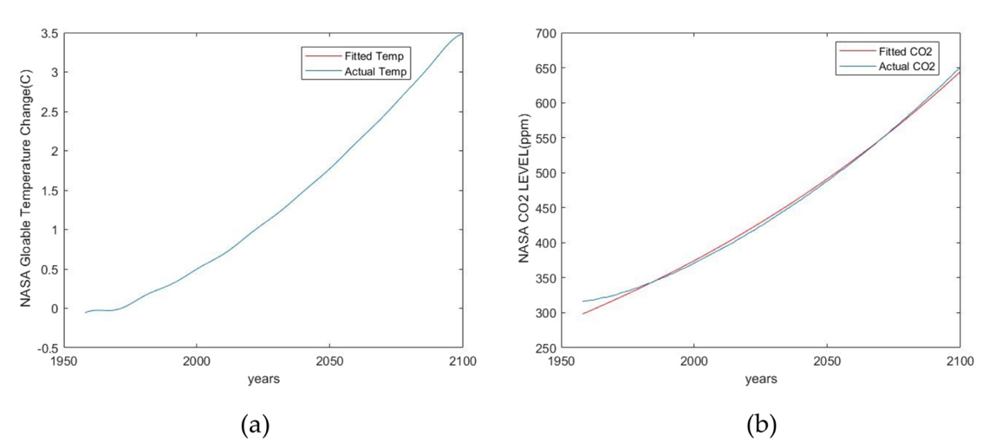

Figure 1.2. Nasa curve fitting output using exponential function for (a) temperature and (b) CO2 concentration Hamden *et al.*13

To reduce the production of greenhouse gases, it has been proposed to covert methane into methanol. This has been proposed as methanol is a liquid at ambient temperature, easily transportable and a valuable commercial product as a precursor to many chemical substituents. The partial oxidation of methane to methanol is illustrated in Equation 1.

Eq. 1

From a chemical perspective, this conversion poses many challenges as methane is a highly stable hydrocarbon due to its tetrahedral symmetry and heterolytic cleavage of each C-H bond requires a relatively large amount of energy of 432.373 kJ/mol.14 Therefore many problems are still prolific in this reaction such as low CH4 conversion, low CH3OH selectivity, and the overoxidation of CH3OH.15,16 The addition of strong acids such as concentrated or fuming sulfuric acid can stabilize CH3OH to prevent overoxidation of methane but it remains unfavorable due to its requirement for harsh conditions.17 Additionally, thermocatalysis requires extreme temperatures and pressures only available at large industrial plants, making its widespread application difficult and unfavorable. Although, the partial oxidation of methane to methanol is less favorable than CO2 this reaction can be achieved using photocatalysis at standard temperature and pressure using light energy.18

## Introduction to Photocatalysis

There are many types of photocatalysts that can be used to perform photocatalytic reactions, organic, inorganic, metallo-organic, and even supramolecular materials. Inorganic photocatalysts such as TiO2,19 WO3,20 C3N4,21 ZnO,22 BiVO4,23 Cu/CeO2 and several zeolite systems have different effects on the photocatalytic activity due to factors such as dopants and band gap.24 Experiments performed in this study were done using the semiconductor titanium dioxide (TiO2). Titanium dioxide (TiO2) or titania is a semiconductor material that has been employed in the field of photocatalysis due to its ability to photodegrade organic pollutants and its accessibility from commercial manufactuers.25 Photocatalytic reactions using titania occur when a photon (light) excites an electron from the valence band to the conduction band, a process referred to as photoexcitation depicted in Figure 1.3 The valence band is the highest energy level fully occupied by electrons and the conduction band is the next available energy level which in the case of titania is empty. The gap between the valence and conduction band is called the band gap. A photon of energy greater than or equal to the band gap is necessary for this transition to occur. When an electron is excited to the conduction band it creates a vacancy or hole in the valence band that behaves as a positive charge due to the absence of the electron. The combination of the electron in the conduction band and the hole in the valence band is referred to as an electron-hole pair and can perform both oxidation (hole driven) and reduction (electron driven) reactions.

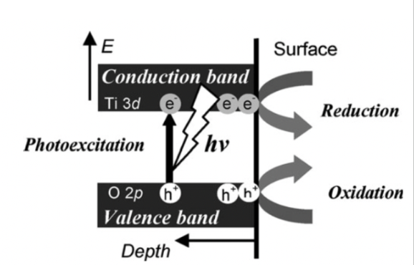

Figure 1.3 Photoexcitation of TiO2 semiconductor photocatalysts and successive photocatalytic reactions3

The position of the valence and conduction band in the material directly influence the types of reactions that can be performed by the photocatalyst. For reactions to occur, charge carriers (electrons or holes) must make their way to the surface of the material in which they can react with the desired reagent. The potential difference created by these charge carriers generate photoinduced reactive species in the photocatalytic reactions. These reactive species are superoxide (.O2) formed from O2 and hydroxyl radicals (.OH) formed from H2O2  or H2O that are mainly involved in the degradation of organic pollutants.26 The chemistry to form these reactive species can only occur if the reductive or oxidative potential is great enough to drive these reactions. This is primarily dependent on the state in which the electron or hole resides in. Electrons in higher electronic states have higher reductive potential while holes in lower electronic states have more oxidative potential. The valence band and conduction band positions with respect to the normal hydrogen electrode (NHE) of these various photocatalysts are presented in Figure 1.4 to illustrate their ability to generate common reactive species.

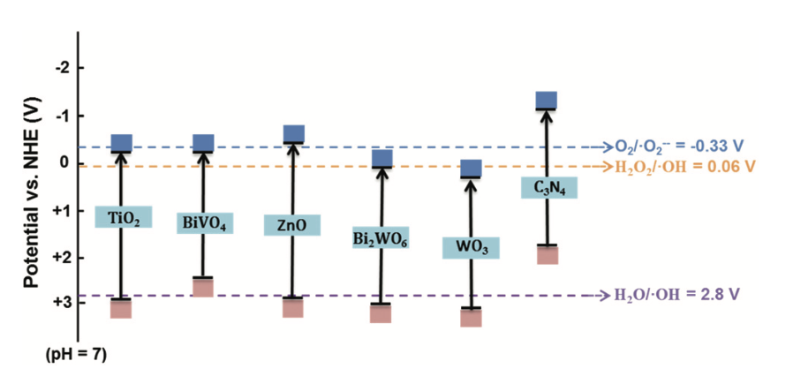

Figure 1.4. The valence band and conduction band positions of common photocatalysts

In addition, Figure 1.4 depicts the band gap of each material. The band gap is a property of the material and differs between photocatalysts based on their band structure and dopants. Titania, the photocatalyst of interest, has a band gap of 3.2 eV absorbing light in the UV region.27

The band gap can directly impact the ability for a material to perform redox reactions. Materials with narrower band gaps can perform photocatalytic reactions using photons of lower energies which introduces the ability to use sunlight to drive these reactions. However, this could reduce the redox potentials of the photocatalyst, preventing the formation of crucial reactive species.

The lifetime of charge carrier, the timescale in which the electron-hole pair recombine also plays a role in the photocatalyst’s ability to perform photocatalytic reactions. If these electron-hole pairs recombine on fast timescales, reactive species cannot be formed, and thus no photochemical reactions take place. Therefore there is a demand to modify the material to enhance the lifetime of these charge carriers. Some studies have introduced the use of sacrificial reagents which will increase the lifetime of electron-hole separation by consuming the electrons.19 In addition, dopants, such as sulfur, can introduce traps states in the band gap of the material to increase the lifetime of charge carriers. The role of sulfur will be discussed in further detail in Section 1.E. However, to characterize our photocatalysts based on differences in band gap and concentration of dopants, we much detail a way to compare our photocatalysts to one another.

## Comparison of Photocatalysts

Heterogeneous photocatalysis has seen tremendous growth over the last few decades resulting in an increasing number of publications in a wide range of journals. However, despite efforts by the editorial boards of the American Chemical Society (ACS) journals to standardize reporting, there remains several inconsistencies in the reporting of photocatalysis studies.28 When monochromatic light is used, it is recommended to characterize photocatalysts based on their photonic efficiency or photonic yield.29 The photonic yield is defined based on the incident photons provided by the light source used in the photocatalytic experiment. Its mathematical definition is provided below,

(1)

Where is the rate of incident photons from a monochromatic source. When reporting the photocatalytic performance of a material, it is important to note that incident photons are used to evaluate the performance, independent of the amount of photocatalyst. As a result, the performance of a photocatalyst must be evaluated under conditions in which the photon absorption and rate are maximized.30 In mass dependence experiments, all photocatalysts follow similar behavior; at low masses the rate of degradation increases linearly as a function of catalyst mass while at high masses a maximum in rate is achieved in which a plateau or “optimal rate” is observed (Figure 1.6).21

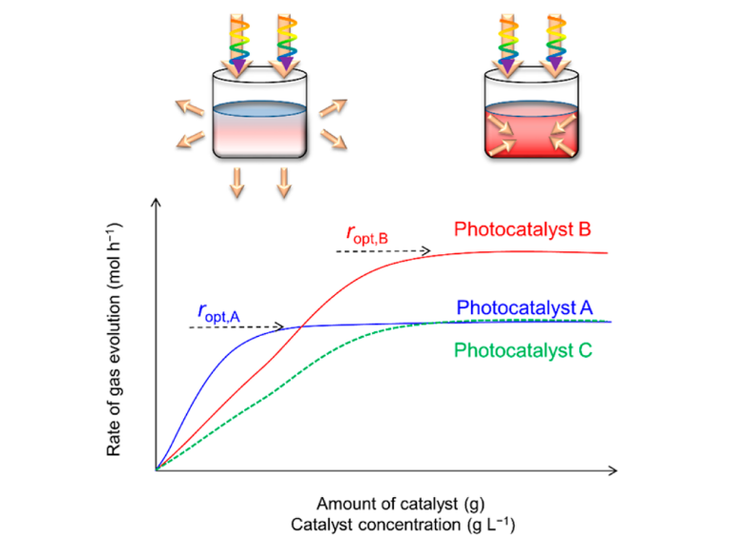

Figure 1.6 Rate of gas evolution, as a function of photocatalyst amount in a given photoreactor. The slopes represent differential conditions, and the plateaus represent optimal catalyst loading conditions

At these low masses known as differential conditions with respect to catalyst mass, the slope varies from one catalyst to another based on absorption coefficient, photon scattering effects, and degree of suspension in solution.21 Under these differential conditions there is no effective procedure to determine the percentage of light absorbed by the photocatalyst and thus photocatalytic efficiency cannot be properly determined in these regions. However, at optimal rates on the plateau regions a maximum in photon absorption is achieved and thus the photocatalysts can be compared to one another. In a regime in which photonic efficiency is the main concern, photocatalyst B is considered the superior photocatalyst with the highest photonic yield.

## Role of Sulfur in Titania

It had been proposed for many years that sulfating semiconductor materials such as titania induces unoccupied states within the band gap. Upon electron-hole pair creation these electron traps can scavenge electrons and increase hole lifetimes.31,32,33 Although these sulfur-induced traps had been proposed and theoretically predicted, there still remained no clear evidence of their existence. Worked performed by Rahmani *et al* reported the first direct evidence for sulfur-induced states deep within the band gap of TiO2.34 In this work, Rahmani used both IR and UV-vis spectroscopy to identify the lowest unoccupied states in titania calcined and sulfur-free titania. They accomplished this using dissociative adsorption of molecular hydrogen on surface oxygen sites to produce surface hydroxyls

which then dehydroxylated to form oxygen vacancies, H2O, and electrons35

Where Kröger-Vink notation is used.36 The electrons produced will fill the lowest unoccupied energy states available and in this case the sulfur-induced states in the band gap. When filled these states produces a UV-vis spectrum that matches the predicted spectrum proposed by Harb *et al* associated with S4+ substituted on a Ti vacancy.37 The peak at 435 nm as which is associated with these trapped states.

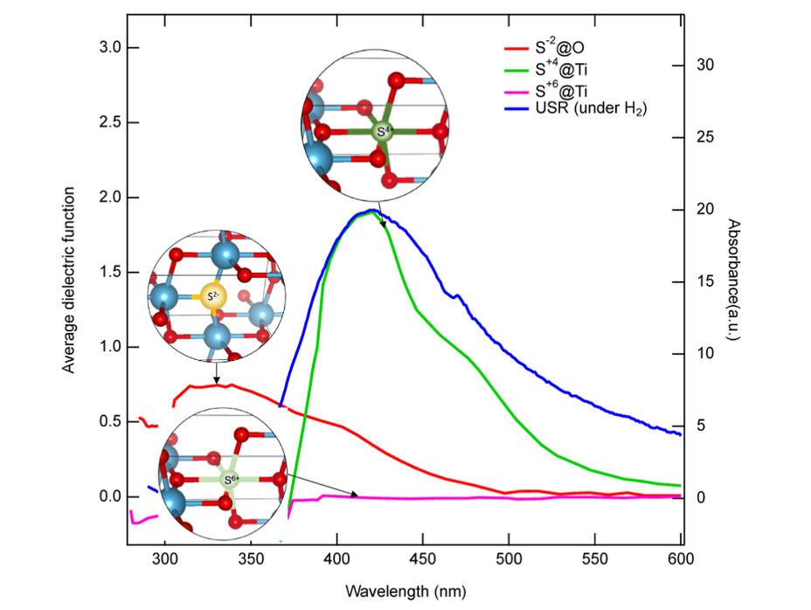

Figure 1.5 Experimental and theoretical UV-vis spectra for sulfur in different configurations on titania

Harb *et al* predicted the density of states for S4+ on a Ti vacancy which shows the trap state at 1.83 eV below the conduction band (Figure 1.6).

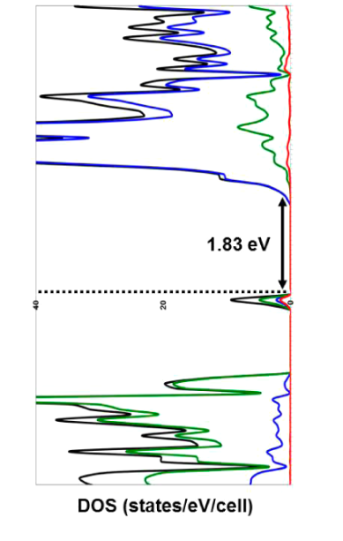

Figure 1.6 Predicted density of states for S4+ @ Ti

Although the energy between the trapped states and the bottom of the conduction band is only 1.83 eV, the observed absorbance at 435 nm (2.85 eV) is related to these trapped being excited deep into the conduction band where the density of states is highest. However, Harb *et al* predicted these states to be fully occupied, below the fermi level. For these states to be fully occupied upon having electrons added they must have been partially depleted. Rahmani *et al* explained this by proposing that titanium vacancies in the material can partially depopulate these sulfur induced defect states. They confirmed the existence of titanium vacancies in the material using X-ray diffraction (XRD) Rietveld analysis. As a result, because this sulfur induced states are partially unoccupied, they can act as an electron trap, confirming their existence.

However, the role of these sulfur-induced electron traps in photocatalytic activity is still unclear and remains debated in the literature. There are contradictory reports in the literature of whether sulfur in titania enhances38 or decreases39 the photocatalytic activity. These discrepancies in experimental results can be explained by the partially occupied sulfur-induced states which contribute to both hole-mediated (direct) and electron-mediated (indirect) pathways. Electron-hole pair formation can occur in two ways. The first is from UV light in which an electron is excited from the valence band to the conduction band leaving behind a hole in the valence band. The second occurs from visible light in which electrons are excited from partially sulfur-derived states into the conduction band, creating a hole in the sulfur states previously discussed by Rahmani *et al.*17 A previous study performed by Bakar and Riberio found that doping of sulfur on titania enhanced the photodegradation of methyl orange with an optimized photocatalytic rate at 2% sulfur. They proposed that the enhanced photocatalytic activity was due to sulfur-induced electron traps increasing hole lifetimes.40 With direct evidence of the existence of these electron traps, we intend to build upon the work done by Bakar and Riberio.

## Overview of Thesis

In this thesis we intend to relate the existence of sulfur-induced electron traps to the photocatalytic activity associated with the degradation of methyl orange. Additionally, we will develop methods to accurately compare different photocatalysts to one another.

# Experimental Section

## Materials and Methods

Commercially available anatase TiO2 materials were purchased from their respective manufacturers: Alfa Aesar (denoted “AA”, Lot. N05C073), Sigma Aldrich (denoted “SA”, Lot. MKCK5713), US Research Nanomaterials (denoted “USR”, Lot. US3490), Nanographi (denoted “NG”) which contains sulfate since it is made using the sulfate proess.41 Sulfate-free anatase was synthesized by Prof. Rachel Austin at Barnard College using sol-gel synthesis from TiCl4 (denoted “BC”)42 followingthe procedure outlined by Li et al.43

The system used to perform calcination and diffuse reflectance measurements is shown in Figure 2.1. Gases were fed to molecular sieve traps, containing molecular sieve (13X, 4-8 mesh), to rigorously remove water vapor. Traps were activated prior to use by heating to 200 °C under the flow of N2 for at least one day. Traps were cooled with ice water during operation. The design allowed for one to be activated while the other was being used over the course of the calcination. Between oxidation (flowing O2) and reduction (flowing H2) reactions, the system is rigorously purged with Ar to prevent the mixing of H2 and O2 which will react explosively if mixed.

Gas lines were heat traced all the way to the calcination reactor and the environmental cell, excluding the mass flow controllers (MFC). The reactor consisted of a 0.5” diameter stainless “U-tube” steel tube placed in a rectangular oven heated with heat tapes installed with thermal paste. The oven temperature was controlled by an Omega ¼ DIN Ramp/Soak/Process temperature controller based on a K-type thermocouple in contact with the catalyst in the U-tube. The USR and NG anatase, denoted as “USR 450” and “NG 450” respectively, were calcined by loading the samples (5.0 g) into the calcination reactor and increasing the temperature stepwise 100, 200, 300, 400, and 450 °C holding for a minimum of one day at each temperature under the flow of 100 sccm of O2 as controlled by an MFC. A low sulfur content sample, “SA 500” was prepared by Christian Geci calcined to 500°C. A sulfur-free sample, denoted “BC 400”, was prepared previously by Akbar Madahvi-Shakib by calcination for several days at 400 °C.

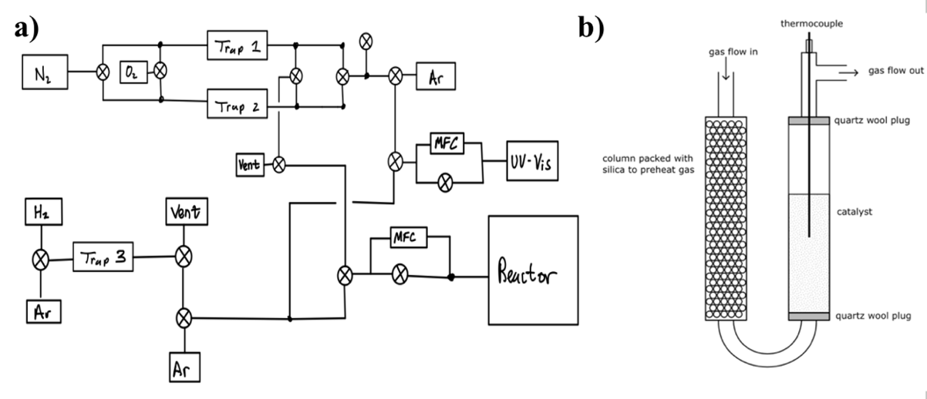

Figure 2.1. a) A schematic of the calcination setup, UV-Vis and praying mantis Harrick cell/environmental chamber, calcination reactor tube, and the dry gas lines of Ar, H2, N2 and O2; b) schematic of calcination U-tube reactor.

Samples were analyzed by ICP-OES on a Thermo Jarrell Ash IRIS dual-view instrument to evaluate the sulfur content of each photocatalyst. The sulfur content is provided in Figure 2.1 below.34

Table 2.1. Sulfur Content of Anatase Photocatalysts

|  |  |
| --- | --- |
| **Material** | **Sulfur Content (ppm)** |
| USR AR | 1395* |
| USR 450 | 1074* |
| NG AR | 2957 |
| NG 450 | 2942* |
| P25 | <500* |
| SA AR | <50* |
| SA 500 | <50* |
| AA | 1121* |
| BC | 0 |

*Measured by Christian Geci

## Batch Reactor Design and Characterization

### Batch Photoreactor Design and LED Characterization

The experimental system used was constituted by the following components and were used to carry out photodegradation experiments (Fig 2.2A):

(a) A 5.18 W 385 nm LED Lamp was constructed by wiring two LEDs (Digikey: LZ1-10UBN0-00U5) in series and mounting the LEDs on opposite sides of the base of an aluminum bar (16.3 cm × 5 mm; length × thickness). A heat sink was mounted to the top of the aluminum bar (Digikey: 345-1126-ND, Pdiss = 11W). The lamp has a spectral energy distribution between 360 – 420 nm (Fig 2.2B). The intensity was varied with forward current between If = 100 – 600 mA (Fig 2.2C) and the intensity was measured with a silicon diode detector using a homemade UV-Vis DRS system.34 (b) The LED sources were inserted into an immersion well implemented with a Pyrex test tube (20 mm × 150 mm; diameter × length), (c) that was inserted into a plastic beaker (50 mL) containing a TiO2 slurry in the methyl orange solution and a magnetic stir bar. (d) A cardboard safety sleeve mounted on top of a stir plate to was used to prevent exposure to the UV light. The magnetic stirrer was used to suspend the TiO2 in the slurry.

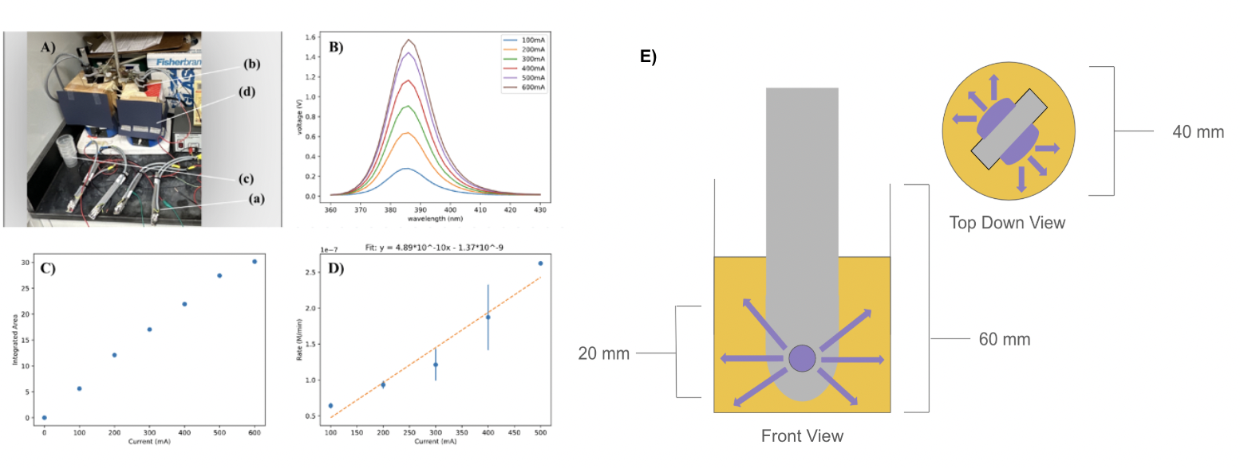

Figure 2.2. A) LED Photoreactor set-up; B) Spectral energy distribution of 385 nm LED Lamp; C) Integrated area of UV-Vis Peak vs. Forward Current; D) Initial rate of degradation of methyl orange using 75µm AA vs. Forward Current; E) Schematic of UV-LED reactor front view and top-down view.

In addition, different LED light sources were employed to cover the wavelengths 390, 395, 410, and 455 nm. The integrated area was calculated from the UV-Vis peak and behaves linearly with forward current (Fig. 2.2C). Initial rate vs. forward current measurements were made using AA (40.1 mg) in methyl orange solution (80 mL) to establish that under the reaction conditions, the initial rate is proportional to photon emission rate from the LED. These rates were measured at the optimal rate regime in which photon absorption is at a maximum (see Sect. III.A.2. The initial rate of the 75µm AA catalyst behaves linearly with forward current, which is proportional to the rate of photon emission.

These rates were measured at the optimal rate regime in which photon absorption is at a maximum. The photon flux of the LED behaves linearly with forward current as indicated by the linear increase in initial rate of 75µm AA (Fig. 2.2D). The rate vs. forward current measurements were made using 40.1 mg of AA in 80.0 mL of methyl orange solution.

### Determination of LED Photon Flux from Integrating Sphere Mesurements

Calibration of the 385 nm UV-LEDs was carried out using a Thorolab PM100D optical power meter with a S-120Z filter for relative power measurements ranging from 10 – 500 mA reported in Figure 2.8. The UV-LED shows a linear relationship to power. The integrating sphere was calibrated with a LS-1-Cal calibration light source with an 8036 ms integration time. Photon flux measurements were made with an ocean optics integrating sphere and operation current of the UV-LEDs at 10mA.

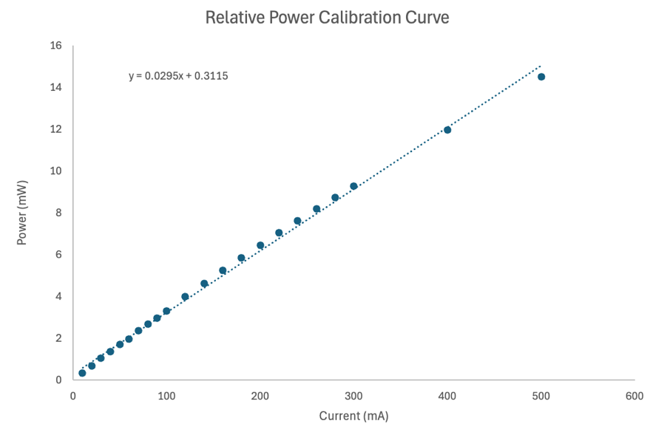

Figure 2.8. Relative power calibration curve for 385 nm UV-LED

## Constant Current Power Supply

### Batch Photoreactor Design and LED Characterization

For photocatalytic reactions a constant current power supply was designed and constructed. A 12V DC power supply was ordered from Digikey that can power the two UV-LED lamp design (Vmin = 7.4V). Wired connections were made to the live (black), neutral (white), and ground (green) components of the power supply to allow it to be plugged into the 120V wall socket (Figure 2.3).

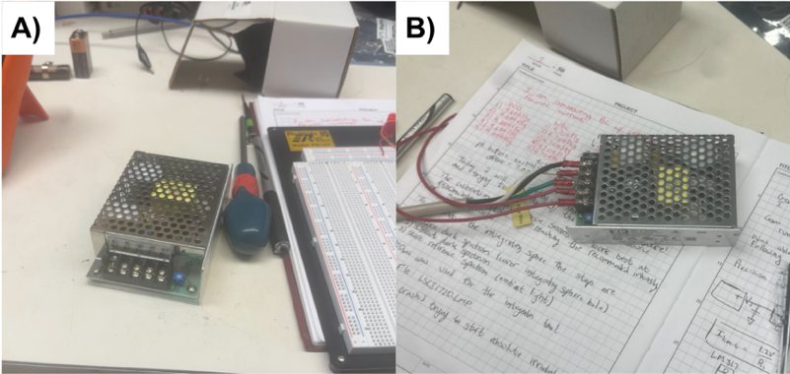

Figure 2.3. A) Power supply before connections and B) after connection were made

The 120V wall socket was measured with a multimeter to determine the live, neutral, and ground components of the socket and cross-checked to ensure compatibility with that of the power supply’s plug. The next step of engineering the power supply was to design the “constant current” component. The idea for the design of this circuit was to choose the simplest circuit possible. The idea of using various diode and transistor circuits was considered, but eventually a circuit element known as an LM317 was chosen due to the complexity of these transistor circuits. The LM317 is an adjustable positive linear voltage regular that can be operated using an input voltage between 3 – 40 V, but will always deliver an output voltage of Vout = 1.2 ± 0.05 V. The LM317 has an input, output, and adjust terminal; the adjust terminal ensures the output terminal voltage is always 1.2 V higher (Fig 2.4).

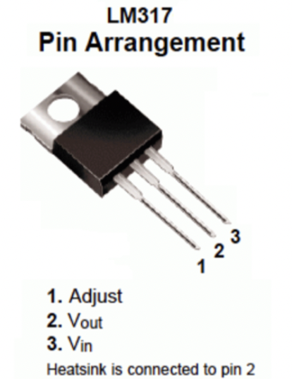

Figure 2.4. Pin Arrangement for LM316

Using the properties of the LM317 a functional constant current circuit powered by the 12V power supply was developed as illustrated in Figure 2.5.

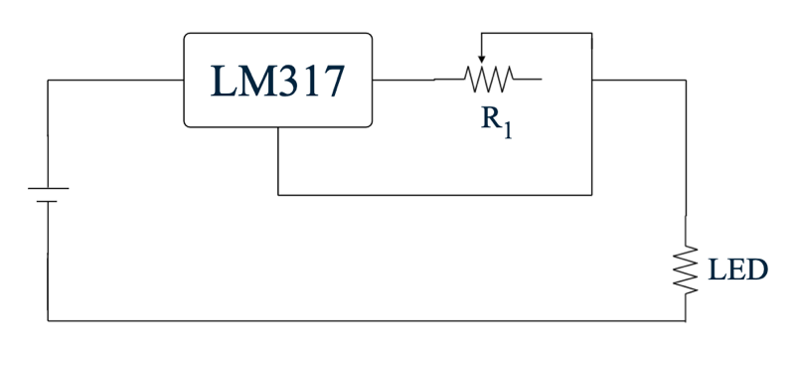

Figure 2.5. LM317 Circuit Diagram

The limited current (Ilim) of this circuit can be controlled by the adjustable resistor of this circuit described by Equation 2.

(2)

The standard current for running photocatalytic reactions with UV-LEDs is 500mA, therefore the necessary resistance of the adjustable resistor (Ωmax = 5 Ω) should be 2.4 Ω for these experiments. Unfortunately, there are two constraints to the simple LM317 power supply design; 1) the chosen power supply voltage output limits the number of LEDs on the lamps to three LEDs (Vmax = 11.1 V) and 2) the simple LM317 circuit does not allow for the measurement of the photon flux dependence of photocatalytic reactions without taking apart the power supply. To work around the second constraint, a second LM317 circuit (denoted S-LM317) was designed to allow the operator to switch between high current (R1 = 2.5 Ω, 500 mA) and low current (R2 = 5 Ω, 250 mA) paths to measure photocatalytic reactions at different photon fluxes (Figure 2.6).

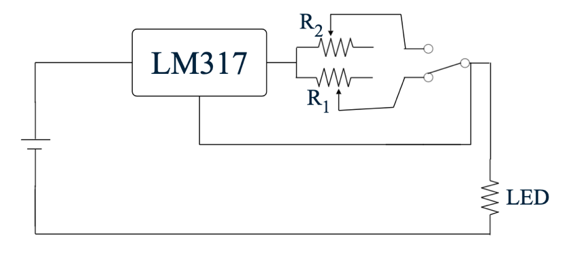

Figure 2.6. S-LM317 Circuit Diagram

Both the LM317 and S-LM317 circuits were constructed in the final design of the constant current power supply in Figure 2.7. The final power supply contains two terminals; the first operates the power supply at a constant current of 500 mA, and the second operates the power supply at either 250 mA or 500 mA depending on the user’s selection. Each terminal has two inputs, the live wire (red) and common wire (black) input. These wires must be screwed down within the terminal’s input to allow for proper electrical contact. Although this design is functional, it can be improved by using banana sockets as the terminals and connecting banana plugs to the LED lamps. This not only will improve the safety of the power supply, but also its accessibility for future users.

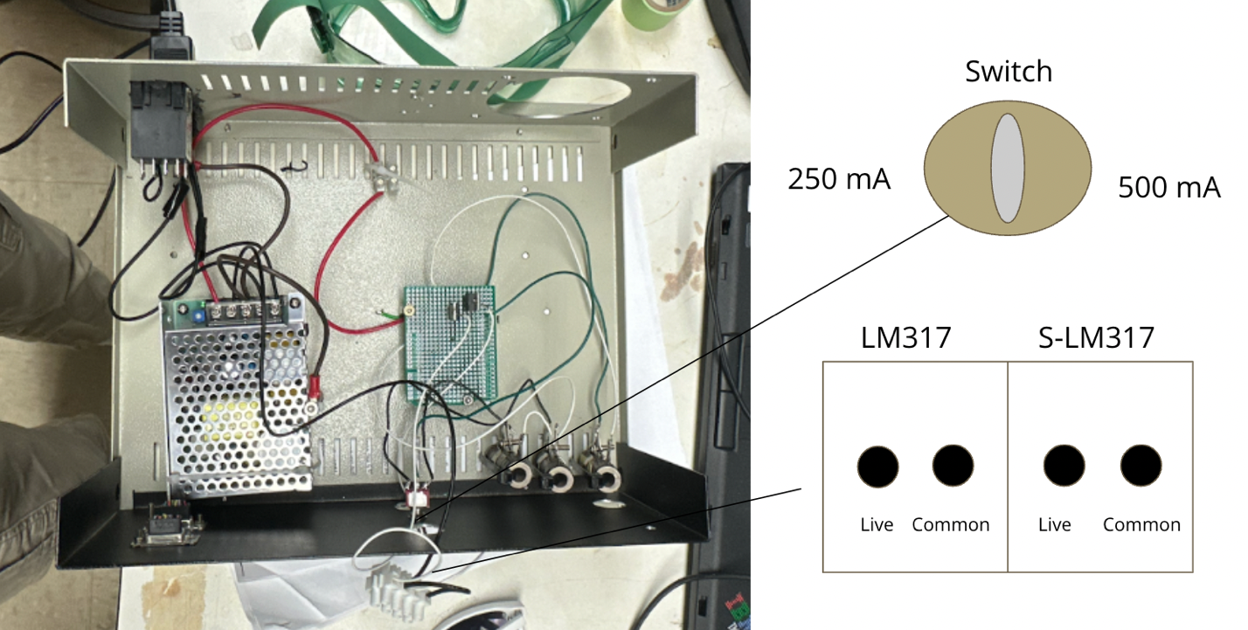

Figure 2.7. Final Power Supply

### Troubleshooting for the Constant Current Power Supply

There are many issues that may arise while operating the constant current power supply. I will address the common problems that I have faced and how I solved these problems:

1. Problem 1: The LED will not turn on
   1. Solution: The power supply might not be on. To correct this, switch on the back left switch. (Also make sure it’s plugged in).
   2. Solution: The polarity of the LED might be reversed. The LED can only function with current flowing from one singular direction. If the common and live wires are reversed current will not flow. To correct this, simply switch the wires.
   3. Solution: I have found that the LM317 may tend to overheat if operating for multiple hours. If this happens the connections made by soldering the wires to the pins might break. To correct this, resolder the LM317.
2. Problem 2: The LED is operating at the incorrect current
   1. Before troubleshooting, ensure that the LED is in fact operating at the incorrect current by measuring the forward current via an ammeter.
   2. Solution: The power supply switch is set to the wrong current. Try flipping the switch to see how that affects the current.
   3. Solution: The power resistors may have been unadjusted. To correct this, switch off the power supply and slide the metal bracket of the power resistor up or down until you achieve the current desired. (This also works if you would like to simply change the current the power supply is outputting).
   4. Solution: Verify that the voltage difference between the output terminal and the adjust is 1.2 V. If this is the case, the LM317 has failed and must be replaced.
   5. Solution: The LM317 circuit has been altered and is not operating as intended. If this is the case, ensure that the output is connected to one end of the resistor (1) and the adjust pin is connected to the other end of the resistor (2). The resistor end labeled 2 must have both the live wire to the LED terminal and the wire connected to the adjust soldered together, this is illustrated in Figure 2.7.

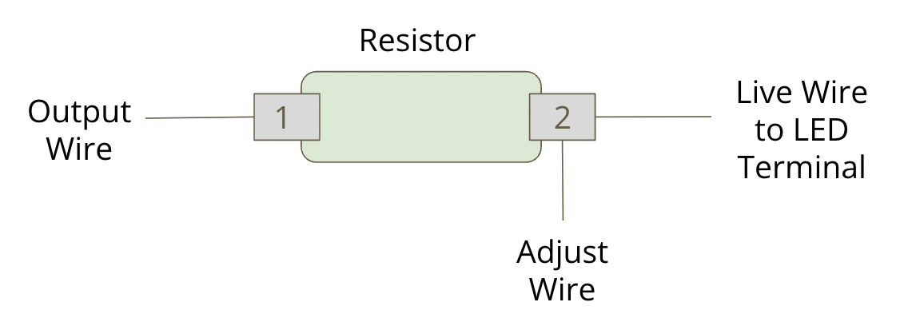

Figure 2.7. Physical depiction of the wiring to the power resistor

## Photodecomposition Reaction

The methyl orange (C14H14N3SO3Na, MW = 327 g/mol, maximum absorption wavelength = 466.6 nm) was purchased from Thermo Fisher Scientific. The safety data sheet of methyl orange describes the compound using the code H301 for acute toxicity if ingested or inhaled. As a result, when preparing methyl orange, gloves, googles, and a face mask is required to prevent accidental inhalation of methyl orange. Methyl orange solutions were prepared by transferring methyl orange powder (122.02 mg, 0.373 mmol) to a volumetric flask (250mL) in deionized water. The methyl orange solution (20mL) was further diluted into a volumetric flask (1L).

Photodegradation experiments were carried out with the LED Photoreactor set-up described in Section 1B and a tungsten halogen lamp set-up. As described by Batoosingh,44 the tungsten lamp setup consisted of a 100 W tungsten halogen lamp, homemade immersion well with cooling jacket, weigh bottle reaction vessel with 20.0 mL of methyl orange solution and the specified mass of catalyst, and stir plate following the procedure outline by Bakar *et al.*40 The spectral distribution of both the 385 nm UV-LED and tungsten halogen lamp are plotted in Figure 2.9 below. Both light sources contain photon energies above the 3.2 eV band gap of anatase.

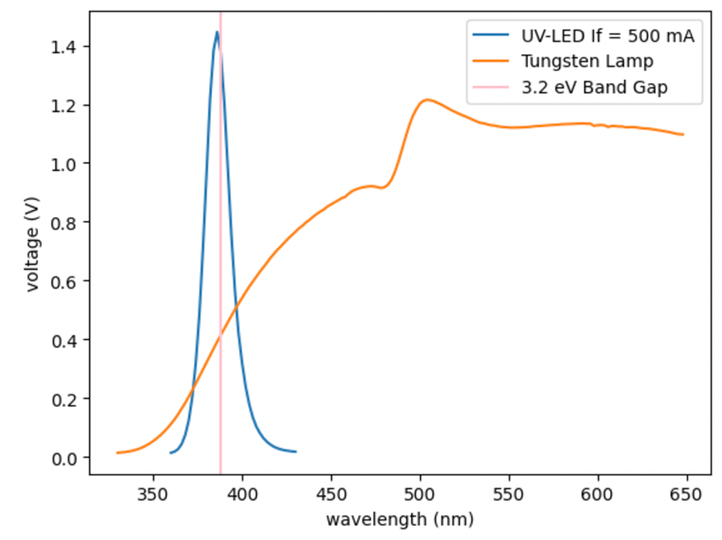

Figure 2.9. Relative power calibration curve for 385 nm UV-LED

For the UV LED experiments, 40.0 mL of methyl orange solution and the specified mass of catalyst was used. The previously prepared 2.98x10-5 M aqueous methyl orange solution was adjusted to neutral pH with 0.1 M NaOH as necessary. A pH meter (VWR Scientific Products model 2100 pH/Temp/mV meter) was used for pH measurements. The concentration of methyl orange was determined using a Vernier UV-vis spectrometer. To determine the concentration of methyl orange, three 2.0 mL samples were taken at preselected time intervals (0, 5, 15, 35, 75, 115 minutes), centrifuged, and recombined into the reaction mixture after analysis. Catalysts were determined to be sufficiently separated in the centrifuge when the baseline in the 600 nm region of the UV-Vis returned to a similar absorbance as recorded for the stock solution. Two centrifuges were used during this experiment one with speeds of 4,000 rpm and 10,000 rpm with the higher rpm centrifuge obtaining better separation. Samples were measured in triplicates and the error was plotted using the least mean square method. The concentration of methyl orange was calculated from the absorbance at the wavelength of 466.6 nm by using a calibration curve made by Batoosingh,44 who determined the molar absorptivity: 25701 cm-1M-1. Photodecomposition experiments were processed using a program named “GushuePhotodecomp” with a JuypterLab interface (See Appendix # for guide and code).

## UV-Vis of Band Gap Measurements

UV-Vis diffuse reflectance spectroscopy (DRS) band gap measurements of photocatalysts were done with a home-made UV-vis DRS system. The UV-vis excitation source was a 75 W Xe lamp (Edmund Scientific) and dispersed in a scanning Czerny-Turner monochromator (HORIBA Scientific Production, IBC) accessory. The instrument was equipped with a Praying Mantis (Harrick Scientific, IBC) accessory for DRIFTS applications and the reflected light from the sample surface was detected with a silicon detector (Edmund Scientific). The detector output was amplified by a low-noise amplifier (model 181, Princeton Applied Research) and averaged with a digital multimeter (Keithley 2000, Keithley Instruments) with a computer interface.34 The UV-Vis signal was aligned to read a signal of 8 V at 467 nm. The TiO2 samples were diluted to 5% in KBr by rigorously grinding KBr and TiO2 together for five minutes. KBr background spectra were measured in triplicates and samples were removed carefully to not disrupt the alignment. The diluted samples were loaded into a sample cup for spectroscopic measurements. Measured spectra were transformed into Kubelka-Munk units and extrapolated using the Tauc Plot method to determine the band gap following the procedure outlined by Makula *et al*.27

## Band Alignment Measurements Using XPS

### Calibration of the XPS

XPS analyses were performed using a SPECS PHOIBUS 100 MCD Plus electron analyzer at a pass energy of 10 eV with a Mg Kα X-ray source working at 100 W and 10 mA with base vacuum of 4x10-10 Torr. All sputtering was performed using a SPECS IQE 100 model ion gun and electronics using Ar+ ions at 5 kV and 10 mA emission current, generating a few uA beam current, operating at 4x10-7 Torr Ar pressure. All XPS spectra were measured using an optics configuration with 8 mm diameter entrance slit, exit slits (B, open), and the large area lens mode (3x magnification). Silver samples were mounted on a VG stub for XPS calibration. Samples were outgassed at room temperatures and a pressure < 10-8 Torr before calibration. Silver foil samples were sputtered with an Ar+ ion beam until contaminant signals were no longer discernable. The Ag 3d peaks were fit using the SpecsLab Prodigy software fitting the peaks with a Voigt peak function and Tougard background (Fig. 2.10A &B); however, the line positions are not accurate. Therefore, a parabolic fit to the top 5% of the peak was used to determine the positions, (Fig. 2.10C) as recommended by Seah et al.45 The spectrometer’s work function was set to a value of 4.543 eV which aligned the Ag 3d5/2 to a binding energy of 368.26 eV corroborating with known literature values for the Ag 3d line positions.45

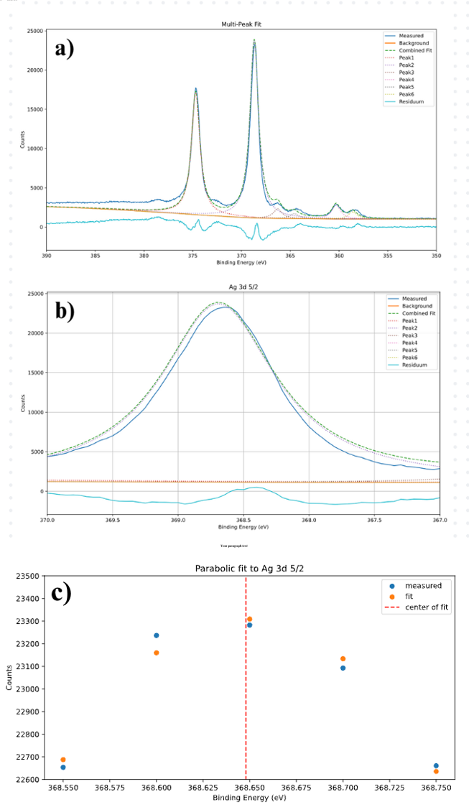

Figure 2.10. a) Multi-Peak Fit of Ag 3d b) Zoomed in Image of Ag 3d 5/2 c) Parabolic Fit of Ag 3d 5/2

### Alignment of Photocatalyst Bands

XPS was used to determine the electronic structure of the photocatalysts’ valence bands. Under the previously described conditions the XPS spectra were referenced to the Fermi level of the spectrometer under ultrahigh vacuum. To determine the valence band maximum (EVB) relative to the vacuum level, the second derivative method was applied to the spectrum as outlined by Maheu *et al.*46 and then adjusted by the work function of the spectrometer. The alignment of the conduction band minimum relative to the vacuum level was established by adding the band gap to the position of the VBM, CBmin = EVB + band gap. The band edges were then aligned with respect to the standard hydrogen electrode (SHE) from the vacuum level using the value suggested by Sprik *et al* (4.44 eV)*.*47

# Results

## Kinetics of Methyl Orange Degradation

### Tungsten Lamp Decomposition Data – Mass Dependence

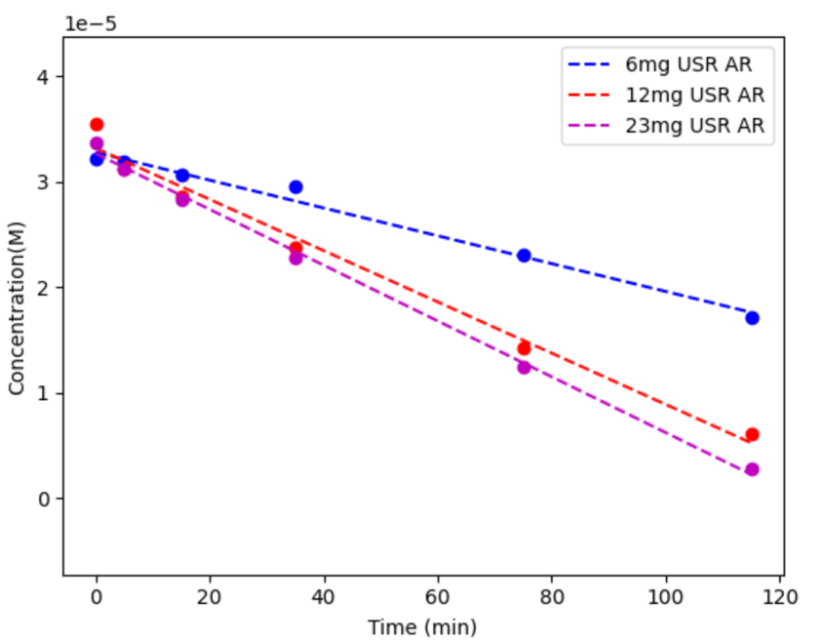

Figure 3.1. Concentration of Methyl Orange versus Time for USR AR Photocatalyst

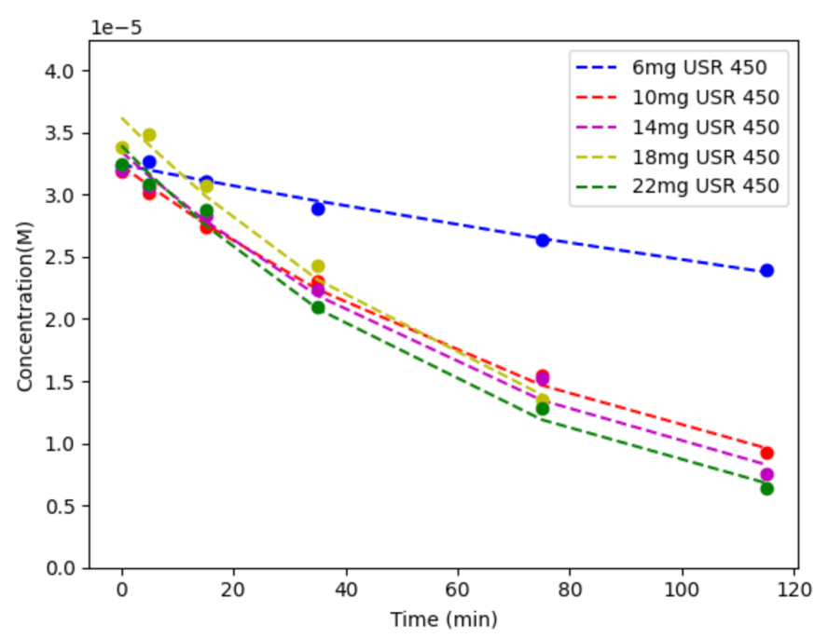

Figure 3.2. Concentration of Methyl Orange versus Time for USR 450 Photocatalyst

Figure 3.1 and Figure 3.2 shows the concentration of methyl orange as a function of total irradiation time as illuminated by a tungsten halogen lamp for the USR AR and USR 450 materials respectively. As mass was increased for both materials are higher degradation rate was observed. Degradation of the methyl orange solution indicates a zeroth order for USR AR and first order for USR 450. Titania particles were difficult to separate and remained in solution after samples were centrifuged. As a result, UV-Vis measurements of methyl orange concentrations were noisy which led to skewed concentration readings. Comparison of the USR AR and USR 450 catalyst indicates a change in reaction order after calcination and that the rate controlling elementary step in the reaction mechanism is different between the two materials. The data suggests that calcination provides and alternative mechanism that improves the photocatalytic activity of the USR material.

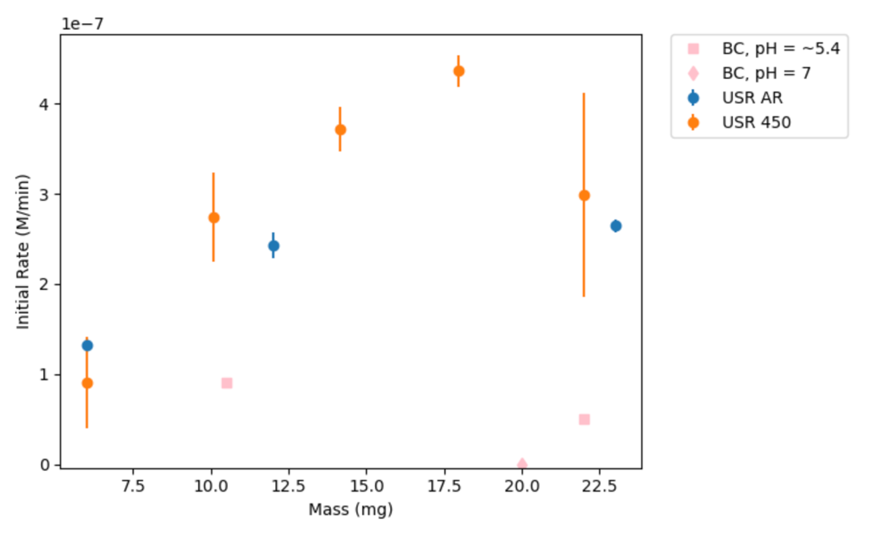

Figure 3.3. Mass Dependence of Photocatalysts Illuminated by Tungsten Halogen Lamp

Figure 3.3 shows the initial rate of methyl orange degradation as a function of photocatalyst mass. At differential conditions, the USR AR appears to degrade at a higher rate and reach the optimal rate at a lower mass than USR 450. Acidic samples of the sulfur-free BC catalyst (pH = ~5.4) were observed to degrade methyl orange at a lower nonzero rate than the USR material. A non-neutral pH solution of methyl orange can influence the rate of photodegradation due to charge carriers on the surface of the photocatalyst.48 Charge carrier effects were minimized by neutralizing the methyl orange solution. Upon neutralization, the sulfur-free BC catalyst was observed to have a negligible photodegradation rate. The data collected supports that sulfur improves the photocatalytic activity of titania catalysts corroborating with findings by Baker *et al*.6

### UV- LED Decomposition Data – Mass Dependence

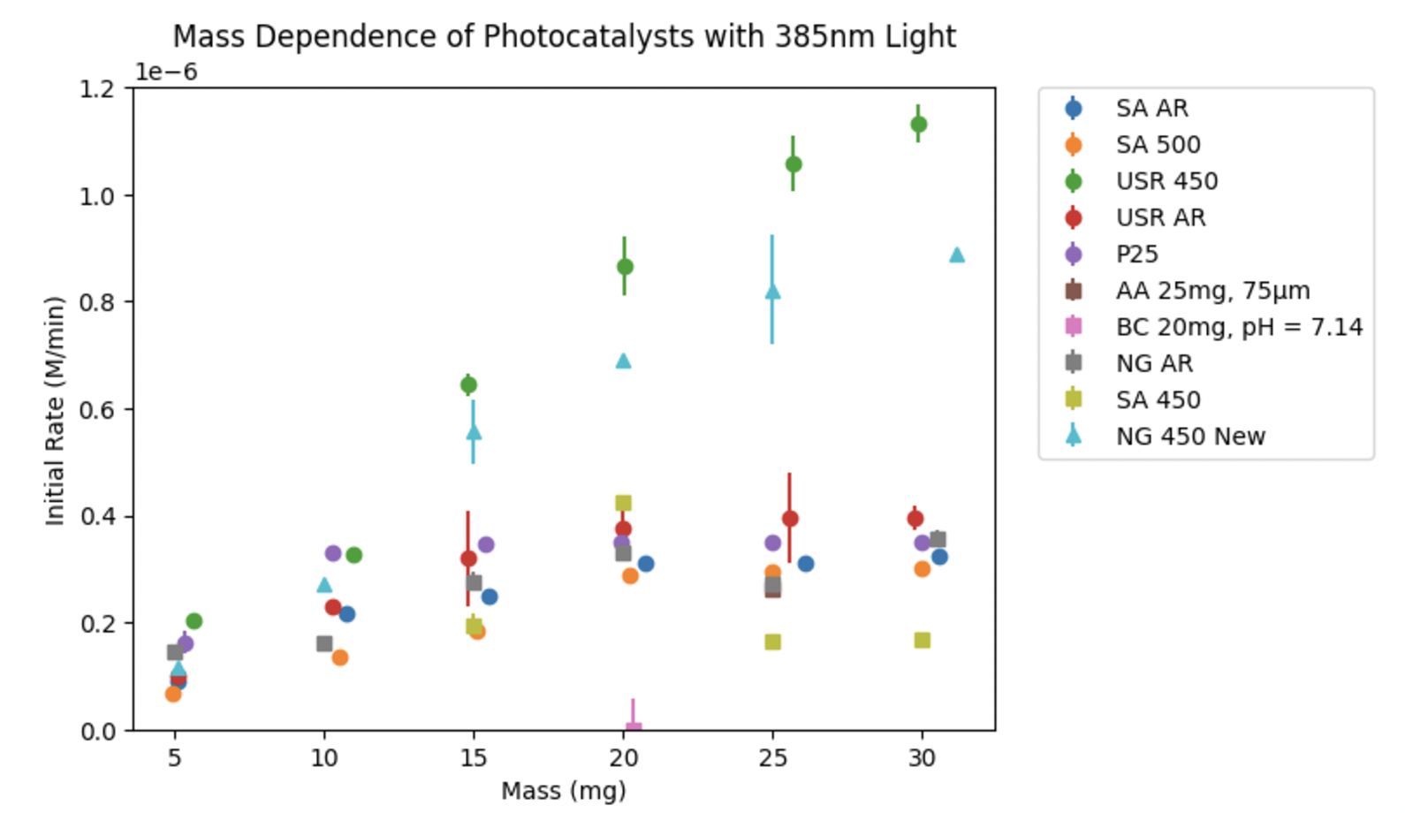

Figure 3.4. Mass Dependence of Photocatalysts Illuminated by 385 nm LED Lamp

Figure 3.4 shows the photocatalytic rate of the decomposition of methyl orange as a function of mass of catalyst illuminated by a 385 nm LED lamp at If = 500 mA. All sulfur containing photocatalysts follow similar behavior; at low masses the rate of degradation increases linearly as a function of catalyst mass while at high masses a maximum in rate is achieved in which a plateau or “optimal rate” is observed.35 At these low masses known as differential conditions with respect to catalyst mass, the slope varies from one catalyst to another based on absorption coefficient, photon scattering effects, and degree of suspension in solution.30 Under these differential conditions there is no effective procedure to determine the percentage of light absorbed by the photocatalyst and thus photocatalytic efficiency cannot be properly determined in these regions. To compare the photocatalytic performance, the reaction rate must be evaluated under conditions in which the photon absorption and rate is maximized. In the optimal rate region, photonic efficiency can be described by the rate of reaction divided by the incident photon flux. The photonic efficiency can then be used to properly compare photocatalysts if the absolute flux is known.30 A single point was taken in the optimal rate regime for AA and BC catalysts at masses of 25mg and 20mg, respectively. Previous photocatalytic degradation studies have reported that the degradation rate of dye solutions is pH dependent.48 Although not directly analyzed in this study, the BC catalyst degraded methyl orange at lower pH in the Tungsten lamp set-up, apparently due to acid on the surface of the BC anatase left over from the synthesis (see Section 3.A.1). To remedy this effect, the BC catalyst was neutralized to a pH value of 7.14. Upon returning the methyl orange solution to neutral pH the non-sulfur containing BC catalyst was measured to have negligible activity as reported in Figure 3.1. The NG and USR photocatalysts exhibit an enhancement in photocatalytic activity when calcined to 450°C. Although calcined to 450°C, the low sulfur containing SA photocatalyst was not observed to have enhanced photocatalytic activity.

### UV-LED Decomposition Data – Wavelength Dependence

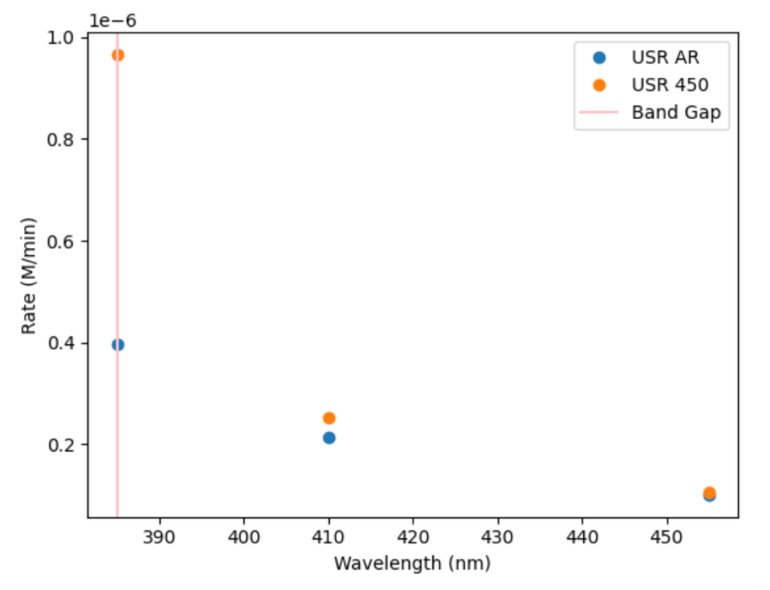

Figure 3.5 Wavelength Dependence of USR AR and USR 450 Photocatalysts

Figure 3.5 shows the wavelength dependence of the photocatalytic activity of USR AR and USR 450 at 385, 410, and 455 nm using the LED lamp light sources operating at If = 500 mA. The photocatalytic activity decreases as the wavelength shifts into the visible light region for both catalysts with USR 450 showing higher activity in the UV region. Absorption of light of photon energy greater than or equal to the band gap of the photocatalyst is necessary for degradation to occur. Both catalysts show a drop off in rate in wavelength below band gap (~380nm), but are nonzero which is not as expected.

### UV-LED Decomposition Data – Particle Size Dependence

We next investigated the particle size dependence using the AA catalyst. The AA catalyst had an optimal rate of 2.6x10-7 M/min showing a comparable activity to the other catalysts with a more extensive mass dependence measurement. Particle sizes of the bulk as-received AA catalyst were not uniform and were analyzed to study its effect on the degradation of methyl orange. Figure 3.2 depicts the photocatalytic rate of degradation of methyl orange as a function of average particle size using AA as received catalysts sieved to different ranges of particle size using a mass of 25mg in the optimal rate regime for this catalyst.

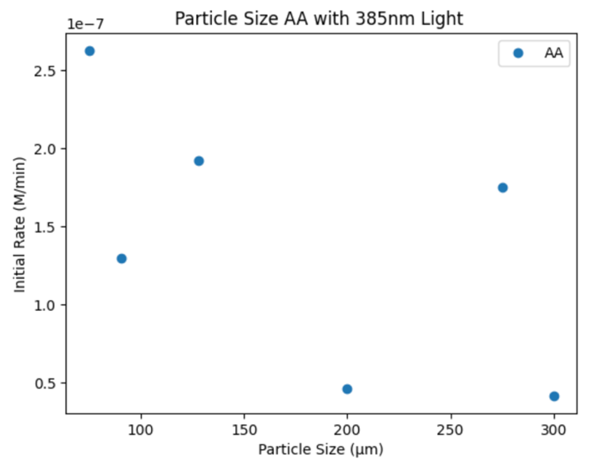

Figure 3.2 Degradation Rate of Methyl Orange vs Particle Size Using AA Catalyst

The optimal photocatalytic rates given in Table 1 for each particle size range show no clear dependence of particle size. As the particle size increased the photocatalytic rate tends to decrease following the same trend measured by Batoosingh using the Tungsten lamp. Larger particles were more difficult to suspend in solution and would aggregate on the bottom of the plastic beaker. The mass fraction of each particle size from the unsieved catalyst was recorded by Batoosingh.44 The mass fraction and particle size kinetics data are reported in Table 1 and are used to determine the contribution of each particle size on the overall rate of the as received catalyst. The mass weighted rate of 1.7x10-7 M/min is in good agreement with the rate of the whole catalyst of 2.6x10-7 M/min.

Table 1. Mass Fraction and Optimal Rate of Each AA Catalyst Particle Size

|  |  |  |  |
| --- | --- | --- | --- |
| Average Particle Size (µm) | Mass Fraction | Optimal Rate (M/min) | Contribution  (M/min) |
| > 250 | 0.159 | 2.2x10-7 | 3.5x10-8 |
| 150 – 250 | 0.241 | 4.7x10-8 | 1.1x10-8 |
| 106 – 150 | 0.169 | 1.9x10-7 | 3.2x10-8 |
| 75 – 106 | 0.169 | 1.3x10-7 | 2.2x10-8 |
| < 75 | 0.262 | 2.6x10-7 | 6.9x10-8 |
| Total | 1.000 | 2.6x10-7 | 1.7x10-7 |

Further data measuring the rate of the as received bulk AA catalyst is necessary to determine if there is any correlation between the measured and calculated total rate for as received catalysts of varying particle sizes. Further analysis of the measured bulk photocatalysts in the optimal rate region indicate USR 450 (high sulfur-containing catalyst calcined to 450°C) as the superior catalyst with the highest photonic efficiency. USR 450°C calcined photodegrades methyl at a rate of 1.13x10-6 M/min, which is significantly faster than P25, known as the gold standard, degrades methyl orange, 3.49x10-7 M/min. This measured increase in optimal rate upon calcining USR to 450°C is consistent with measurements by Batoosingh and demonstrates batch to batch reproducibility since these experiments used a different batch from US Research than was used in the Tungsten lamp experiments. USR 450 shows promise in elucidating the role of sulfur on photocatalysts because of its improved performance over the standard material P25.

## Determination of Photon Flux and Methyl Orange Photonic Yield

The photon flux of the 385 nm UV-LED was determined by measuring the total photons at 385 nm over an integration time of 8036 ms at 10 mA. The photon flux was calculated as follows:

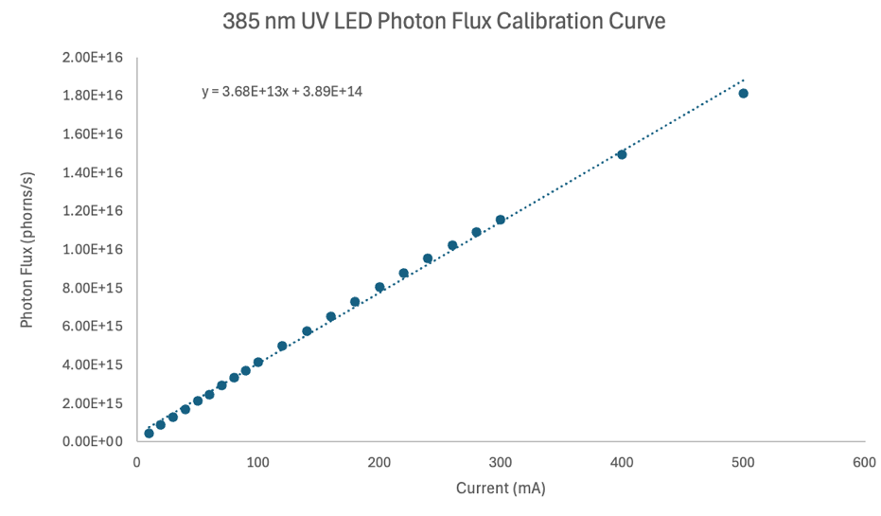

Figure 3.3 Photon Flux Calibration Curve for 385 nm UV-LED

The photon flux measurement at 10 mA was used with the relative power calibration curve (Figure 5) to create a photon flux calibration curve. The photon flux calibration curve illustrated in Figure 3.3 was used to calculate the photon flux at the current in which the methyl orange degradation kinetics measurements are made (photon flux (500 mA) = 1.81 * 1016 photons/s). The photonic yield is calculated for USR 450 utilizing Equation 1 as follows:

(3.1)

*Note: The rate in the optimal rate regime must be converted to methyl orange atoms / min.49

* 100

114%

The calculated photonic yields are shown in Table 3.1

Table 3.1 Optimal Rate and Photonic Yield of USR and NG Catalysts

|  |  |  |
| --- | --- | --- |
| Catalyst | Optimal Rate (M/min) | Photonic Yield |
| USR AR | 3.96 * 10-7 | 1.10 % |
| USR 450 | 1.13 * 10-6 | 3.15 % |
| NG AR | 3.57 * 10-7 | 0.99 % |
| NG 450 | 9.23 * 10-7 | 2.57 % |

## Band Gap Measurements

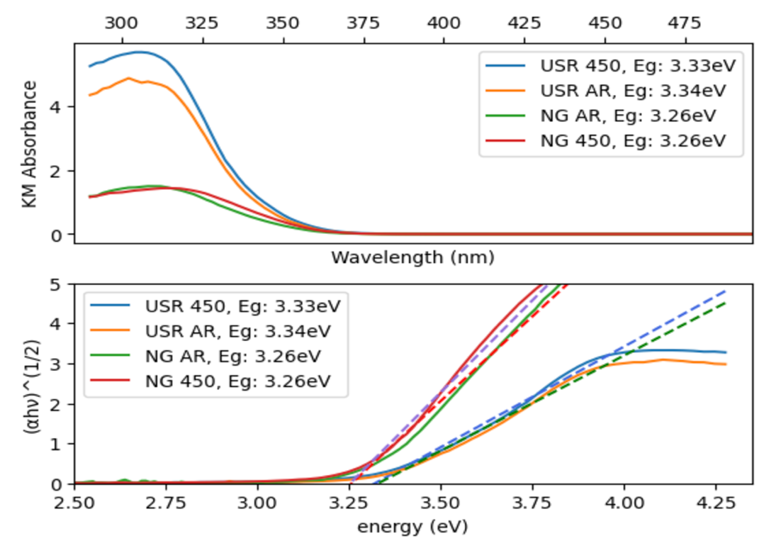

Figure 13. Top) Absorption Spectra Plotted in Kubelka-Munk Units and Bottom) Tauc Plots

To estimate the band gap energy by UV-Vis DRS, 0.5% by weight of USR AR and USR 450 and 5% by weight of NG AR and NG 450 in KBr were prepared by grinding in a mortar and pestle to get a homogenous mixture. The absorption spectrum of each sample in plotted in Figure 3.5a. Figure 3.5b is the so-called Tauc Plot obtained from Figure 3.5a. The band gap value has been calculated using Tauc’s Equation (3) for an indirect band gap material27:

(3.2)

Where is the energy-dependent absorption coefficient, h is Planck’s constant, n is the photon’s frequency, *Eg* is the band gap energy, and B is a constant often termed as the band tailing parameter whose value changes with the material. The g factor depends on the nature of the electron transition; for an indirect transition, the value of g is equal to 2.A comparison of the band gaps of USR AR, USR 450, NG AR, and NG 450 which were reported in this study to be 3.33, 3.34, 3.26, and 3.26 eV, respectively, indicate no significant difference in band gap between calcined and as received catalyst. The absorbance of the USR catalyst appears higher after calcining.

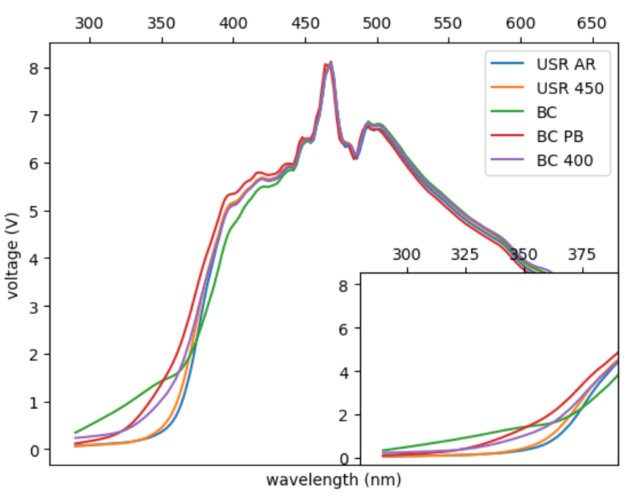

Figure 3.6. Raw UV-Vis Spectra of Photocatalysts

The absorbance of the BC catalyst before calcining was measured to have the lowest absorbance of any of the catalysts. After calcining to 400°C and BET analysis the absorbance of the BC catalyst was measured to increase suggesting that calcining increases the absorbance of the photocatalyst. Closer analysis of the raw BC UV-Vis spectra show that the samples are not off-axis.

Table 3. Band Gaps of Titania Catalysts

|  |  |  |  |  |  |  |  |
| --- | --- | --- | --- | --- | --- | --- | --- |
| **USR AR** | **USR 450** | **BC** | **BC PB** | **BC 400** | **NG AR** | **NG 450** | **P90** |
| 3.25 eV | 3.27 eV | 3.01 eV | 3.26 eV | 3.22 eV | 3.26 eV | 3.26 eV | 3.02 eV |

The approximately estimated band gap values are reported in Table 3. The USR, BC PB, and BC 400 catalysts have band gaps that are comparable to reported literature values for anatase catalysts.50 The band gap for the sulfur free BC catalyst is much lower and broadens after calcining.

## XPS P90 Valence Band Measurements

The valence band of the P90 photocatalyst was measured using XPS and fitted with a Fermi edge fit plotted in Figure 3.4.

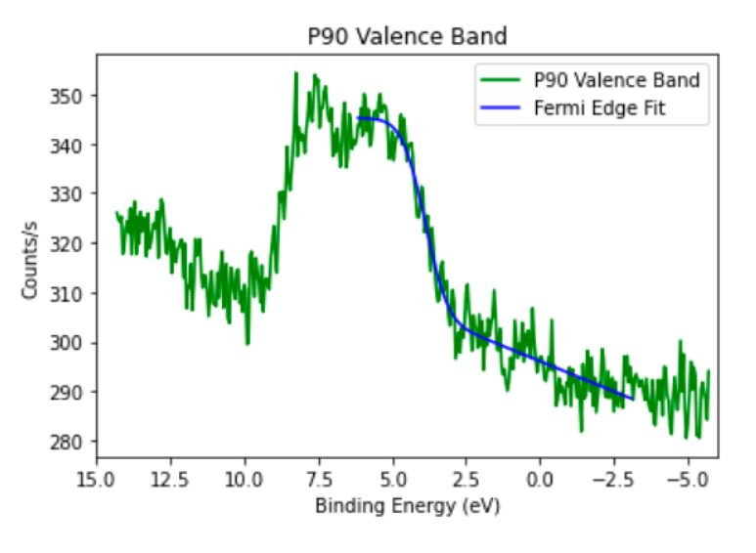

Figure 3.4. Measured P90 Valence Band fitted using a Fermi edge fit

The valence band maximum (EVB) relative to the vacuum level was determined using the second derivative (Figure 3.5) method outlined by Maheu *et al.*46

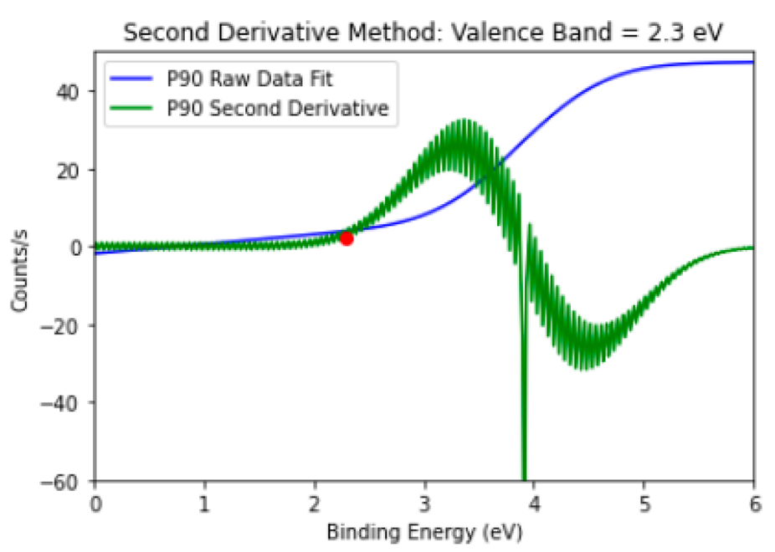

Figure 3.5. Second Derivative Method of P90 Valence Band

The energy level was adjusted by the work function of the spectrometer,

(3.3)

then aligned with respect to the standard hydrogen electrode (NHE) from the vacuum level using the value suggested by Sprik *et al* (4.44 eV)*.*

(3.4)

The alignment of the conduction band minimum relative to the vacuum level was established using band gap measurements of P90 (Eg = 3.0 eV) determined in section 3.C.

(3.5)

The P90 photocatalyst was then plotted against other photocatalysts in Figure 7.

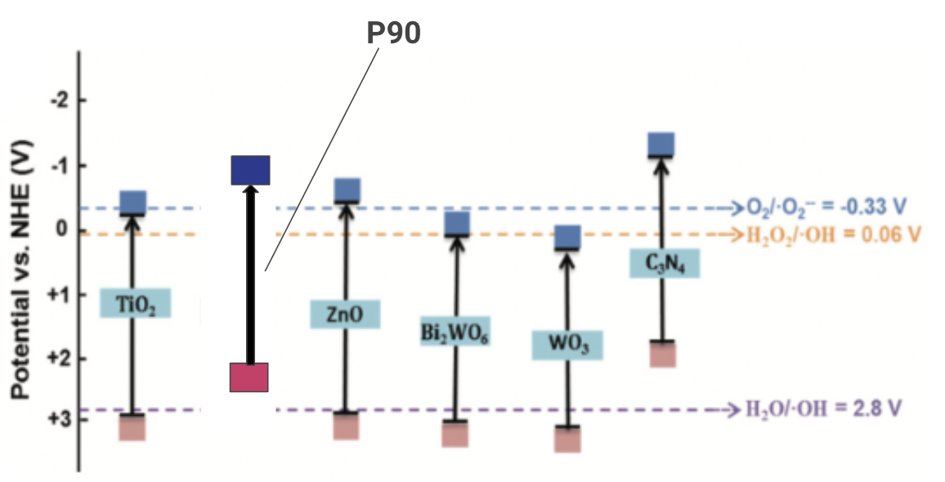

Figure 3.6 Photocatalyst P90 Plotted Against Various Other Photocatalysts with Respect to The Normal Hydrogen Electrode (NHE).

# Discussion

## Existence of Electron Traps – Rahmani Paper, Harb Paper

The existence of electron traps can be related to the enhanced activity upon calcination of the photocatalyst in the photodegradation of methyl orange performed in both the UV-LED and Tungsten lamp set-ups. As previously mentioned in Section 1.E, Rahmani *et al* was able to provide evidence for the existence of sulfur-induced electron trap states in TiO2 matching predicted UV-vis spectra associated with sulfur atoms substituted on a titanium vacancy in the +4-oxidation state. This was achieved using UV-vis diffuse reflectance spectroscopy under the flow of hydrogen gas, forming electrons that fill the lowest unfilled energy state (in this case the sulfur states). The density of states for this sulfur species was predicted by Harb *et al* and is given in Figure 1.6. However, Harb predicted these states to be fully occupied and below the Fermi level, so to have added electrons to those states in the UV-vis experiment they must have been partially depleted.

Rahmani found evidence of these states being partially unoccupied. By using XRD Rietveld analysis, Rahmani was able to identify titanium vacancies (excess oxygen) which deplete the sulfur states, leavimnh

## Bakar and Riberio Methyl Orange Discussion, Refutes, Explanation of their work, how our work builds upon it

## Evidence of electron traps enhancing photocatalytic activity – NG and USR Catalysts, BC no sulfur

## TAS Measurements, Density of States, Implications for Photocatalysis

## Conclusions and Future Work

## Summary of findings, Effect of pH on photocatalysis, Mechanism of methyl orange degradation.

# 

# Appendix/Supplemental Materials

## A.1 Photodecomposition Python Program

### 1. User Manual

**Installation and Setup**

**Installing Anaconda – Navigator**

Anaconda Navigator is a desktop graphical user interface (GUI) that allows the user to organize and launch various computer programs Spyder, R, and JupyterLab. To install Anaconda Navigator, open a terminal application (Anaconda Prompt on Windows). From the terminal, run the following command:

conda install anaconda-navigator

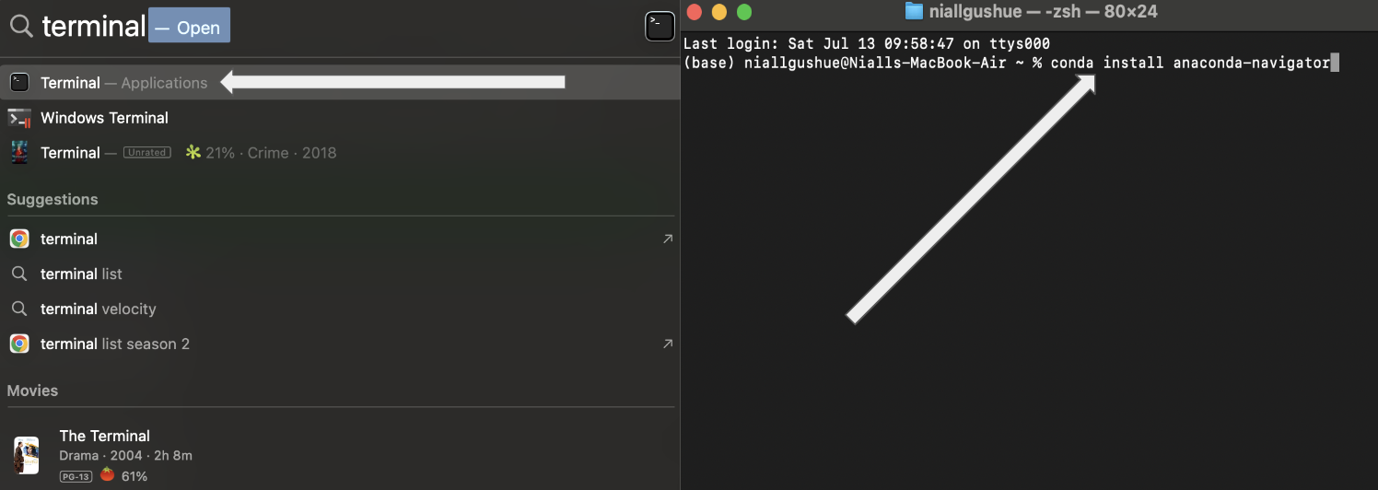

**Launching Jupyter Notebook**

Upon the installation of Anaconda Navigator, the user should now be able to launch the JupyterLab program from the Anaconda Navigator home screen.



JupyterLab is an interactive web-based user interface that allows for organization of various computational projects compatible with Python. JuptyerLab should launch on your local web browser. The projects created in JupyterLab are known as “Notebook kernels”. To launch a Notebook, first choose the directory you would like to work out of (keep in mind that all files used in the project must reside within this directory). For this guide I have used the directory:

Desktop/Research/Research CUGR Summer 2024/UV-Vis Photodecomposition/User Guide

To launch a Notebook kernal, click the Python 3 Notebook button. Once launched, the user should be presented with a command line. Press command + S to save to the directory and give the Notebook a name.



**Installing GushuePhotodecomp**

In order to run the Photodecomposition program, the user must ensure that it is in the correct directory. The latest version of Python must be installed first. This program can be installed from the website: <https://www.python.org/downloads/>. The folder named “site-packages” installed in the Python folder is where the GushuePhotodecomp program must be installed to. This can be done by dragging the file from Desktop or Downloads to the site-packages folder. To access this folder use the following directory:

Macintosh HD/Users/(User Name)/anaconda3/lib/python3/site-packages

Once installed the user will now be able to analyze UV-Vis Decomposition data formatted into excel files.

**Running Decomposition Program**

**Reading in Photodecomposition Excel Files**

Along with the code file for the program, three excel files containing data collected from real decomposition experiments will be analyzed, 385 LED USR AR 5mg 6-17-24 UG.xlsx, 385 LED USR AR 20mg 6-13-24 UG.xlsx, and 385 LED USR AR 30mg 6-13-24 UG.xlsx. The naming convention for these files is: **wavelength.lightsource.photocatalyst.mass.date.** In these experiments, the photocatalyst USR as received was ran at 5mg, 20mg, and 30mg masses using a 385nm LED lamp. First, the program must be imported. Type the following code:



To run the code and exit the command line, press Shift + Enter. Once the program is imported, the files can be read in. The program is compatible with two types of photodecomposition files, those with a single data point measured at each time and those with three separate measurements at each time which must be averaged together in the code. Averaging these three points together will result in the code returning error bars and uncertainties in the calculated rates. To read in the excel files, type the following code setting an appropriate name to the Experiment.

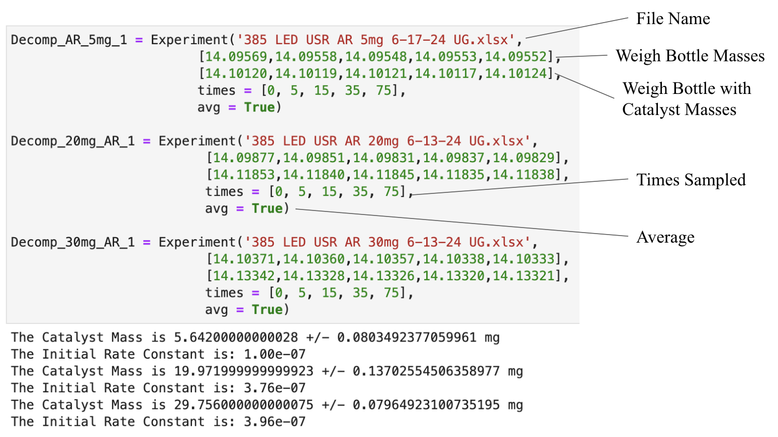

In this code the variable **Decomp_AR_5mg_1** is cast as an object of class Experiment. When calling this class, the user must first input the name of the data file that is to be analyzed as part of the experiment. Next, in the procedure of each experiment, the mass of the weigh container and the weigh container with the catalyst are measured five times each to accurately determine the mass of photocatalyst used. This data is entered as a list within the Experiment argument. The times in which the photodecomposition was sampled is entered by using “times =” followed by a list of times. The avg argument is used to state whether the data was taken in triplicates (and needs to be averaged) indicated by True or was taken in single data points which would be indicated by False. Although not shown in the figure above, arguments “current” and “LED_wavelength” can be set for experiments studying current and wavelength dependence. Additionally, the argument “calibration_wavelength” which is set to 466.6 nm for methyl orange can be changed here as well to use a different wavelength to study the decomposition. When the Experiment is first read in, the program will print the mass and its uncertainty as well as the initial rate of the decomposition.

**Photodecomposition Program Functions**

The program was designed to have built in functions of the class to improve the speed at which the data can be processed. Functions built into the Experiment the user has created must be done using the following format: **ExperimentName.FunctionName().** For example, to plot the decomposition, the user must call the function **plotdecomp()** (shown in the next section).

**plotdecomp()**

The function **plotdecomp()** will create a figure of the photodecomposition and legend including the stock solution and the absorbances at each time point.

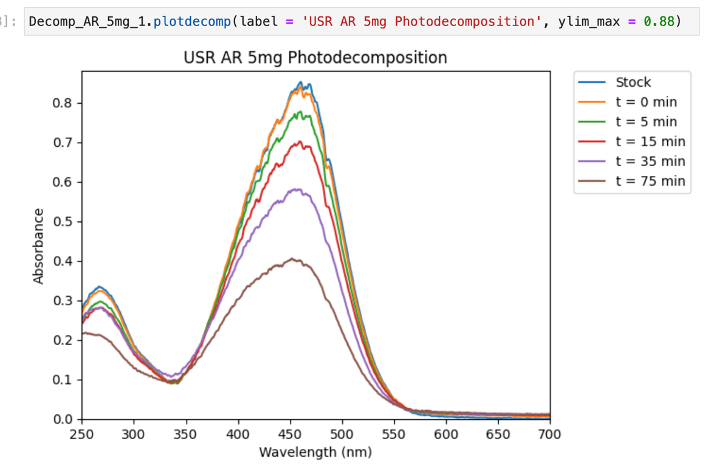

The function takes two arguments, label which will name the figure and ylim_max which will set the maximum y-axis value for the figure (automatically set to 0.88). For the 20mg Experiment, the user would simply type,

**Decomp_20mg_AR_1.plotdecomp(label = ‘USR AR 20mg Photodecomposition)**

**plot_ratetime()**

The function **plot_ratetime()** will plot the concentration vs time of the methyl orange photodecomposition. This function automatically converts from absorbance to concentration using the absorptivity of 25701 cm-1 M-1 determined from a calibration curve constructed by Leah Batoosingh.

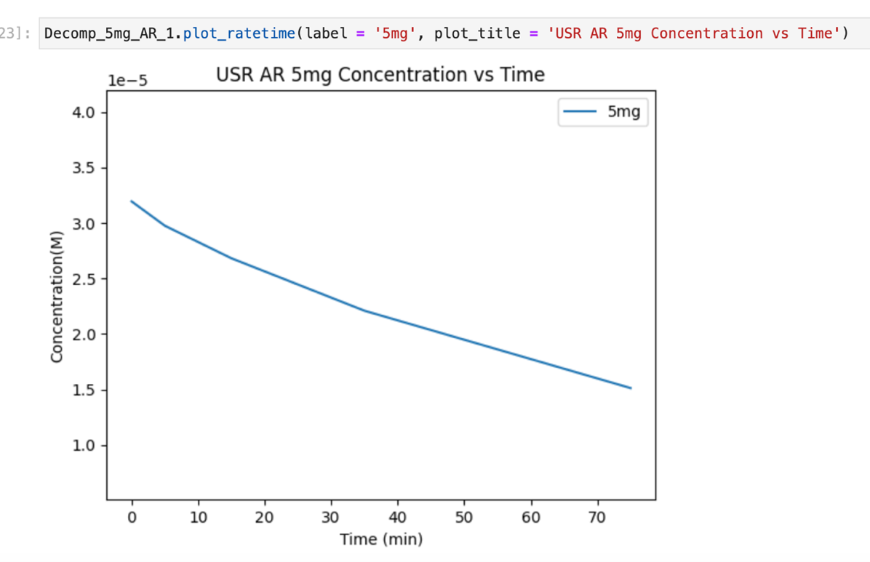

The function takes two arguments, label which will set the name of the line and plot_title which will set the title of the graph. For the 20mg Experiment, the user would simply type,

**Decomp_20mg_AR_1.plot_ratetime(label = ‘20mg’, plot_title = USR AR 20mg Concentration vs Time’)**

The user might also like to plot multiple decompositions on the same graph. This can be done by running multiple **plot_ratetime()** functions in the same command line as seen below.

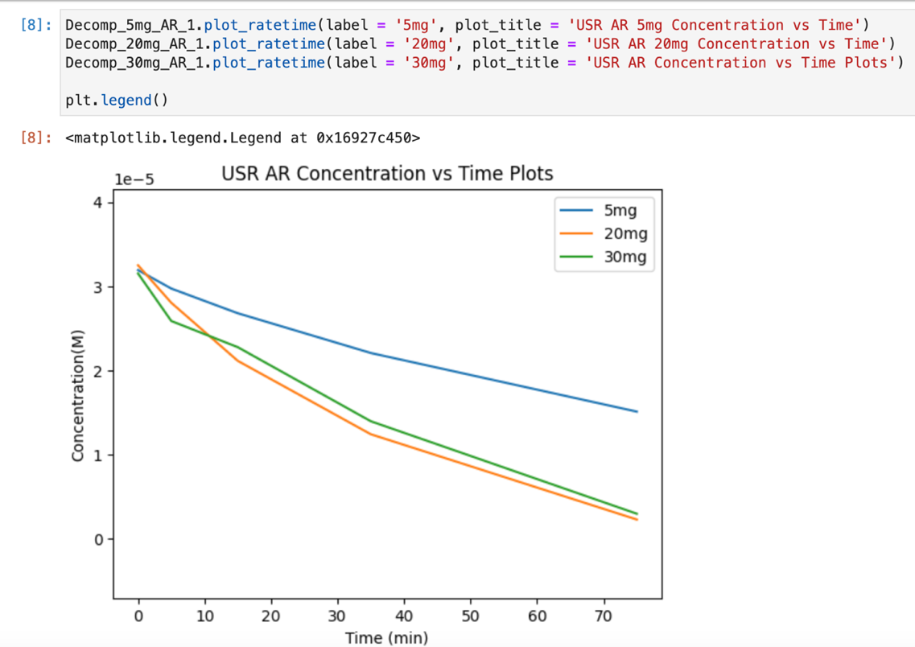

The user must type plt.legend() after the plot_ratetime() functions to create a legend. Furthermore, notice how the title of the graph is set by the last function that is called.

**compare_fit_quality()**

The function **compare_fit_quality()** takes no arguments and will print the chi squared values of the linear and exponential fit. The function will then tell the user which fit is better.

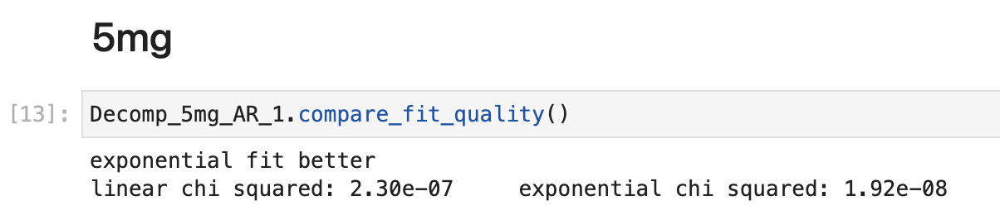

For the 20mg Experiment, the user would simply type,

**Decomp_20mg_AR_1.compare_fit_quality()**

**plot_expfit() and plot_linearfit()**

These functions take no argument and will plot the exponential or linear fit respectively. These functions will print the equation of the fit. Coupling these functions with the **compare_fit_quality()**, the user may choose which fit is best suited for a particular decomposition experiment.

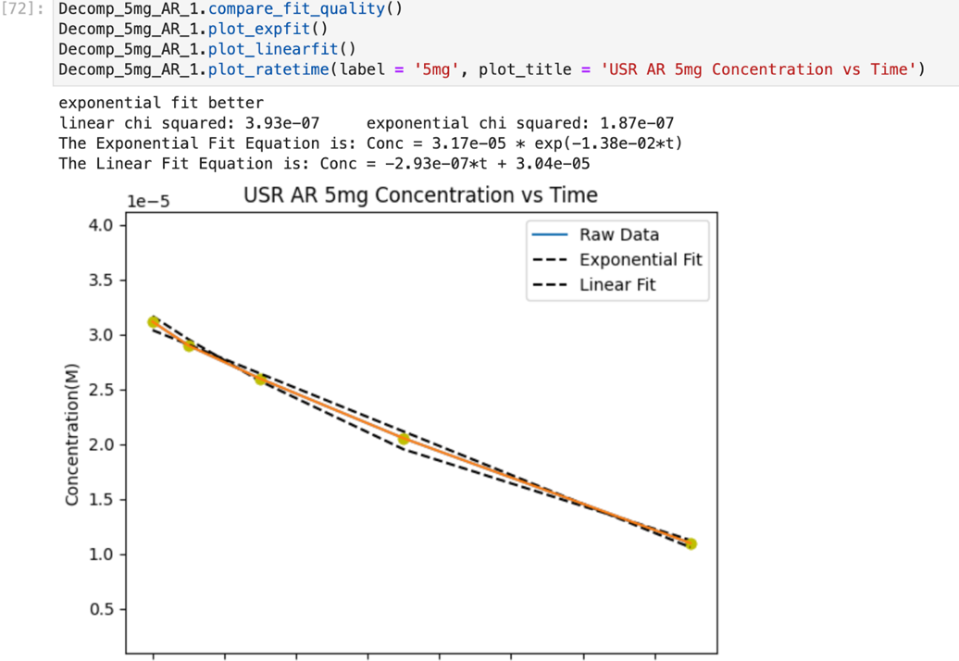

For the 20mg Experiment, the user would simply type,

**Decomp_20mg_AR_1.plot_expfit()** or **Decomp_20mg_AR_1.plot_linearfit()**

**Program Rate Constants**

In order to compare the photocatalysts the user intends to study; it is imperative to determine the rate constant of the photodecomposition. If the reaction fits with a linear fit, the reaction is zeroth order, and the rate constant is simply the magnitude of the slope. If the reaction fits with an exponential fit, the reaction is first order, and the rate constant is the magnitude of the exponential constant. To compare between zeroth order and first order reaction rate constants, the user must use the initial rate. In this section it will be discussed how to determine and set rate constants.

**Printing Rate Constants**

To print the zeroth order (linear) or first order (exponential) rate constants for a particular experiment the user can simply use the formatting **Experiment.linear_rate_constant** or **Experiment.exp_rate_constant**.

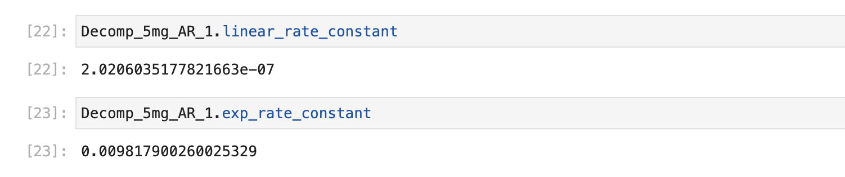

For the 20mg Experiment, the user would simply type:

**Decomp_20mg_AR_1.linear_rate_constant** or **Decomp_20mg_AR_1.exp_rate_constant**

However, if the user would like a more formal print out of the rate constant that includes uncertainties, the user may call on functions that take no arguments known as find_**exp_rate_constant()** and **find_linear_rate_constant()** to perform this.

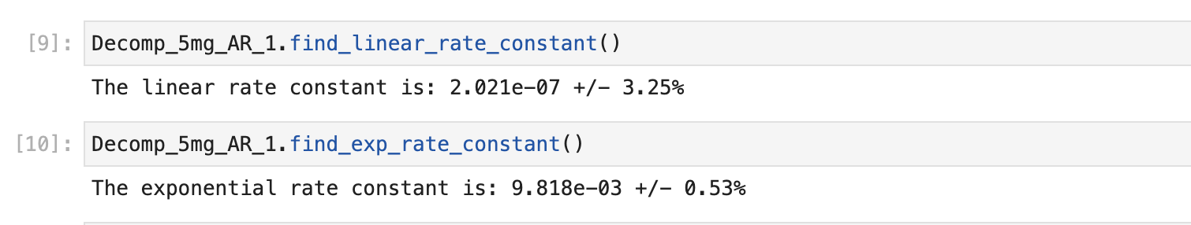

For the 20mg Experiment, the user would simply type:

**Decomp_20mg_AR_1.find_linear_rate_constant**

or

**Decomp_20mg_AR_1.exp_rate_constant**

**Initial Rate and Overrides**

At very short time intervals, the exponential decay is approximately linear and thus the initial rate will be the linear slope of this initial decay. For a linear decay the initial rate will simply be the slope. The initial rate can be used to compare zeroth and first order reactions. To have the initial rate constant printed off, the user must call the function **find_initial_rate_constant().** This will automatically determine if a linear if exponential fit is better and return the value of the initial rate accordingly. The function takes two arguments the first is known as override. This override allows the user to manually select whether a linear or exponential fit is better. The second argument is exp_estimate. This argument allows the user to choose a tighter estimate of time interval from 0-2. The following code will display these arguments:

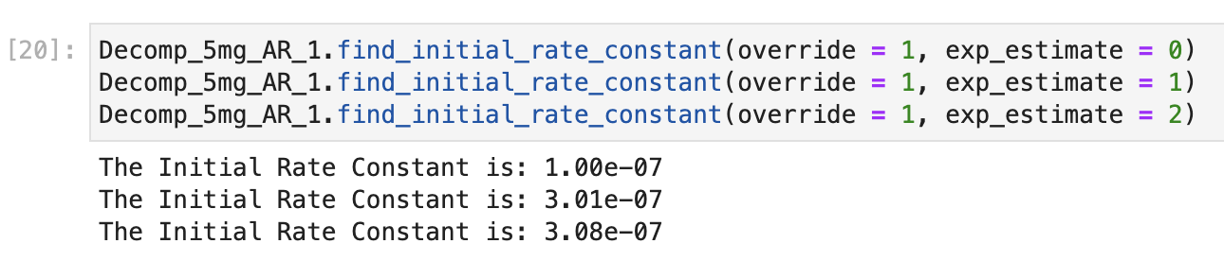

As it can be seen, the 5mg Experiment has been manually set to be a first order initial rate. The rate can also be estimated tighter and tighter by increasing the number of exp_estimate.

**Dependence Experiments**

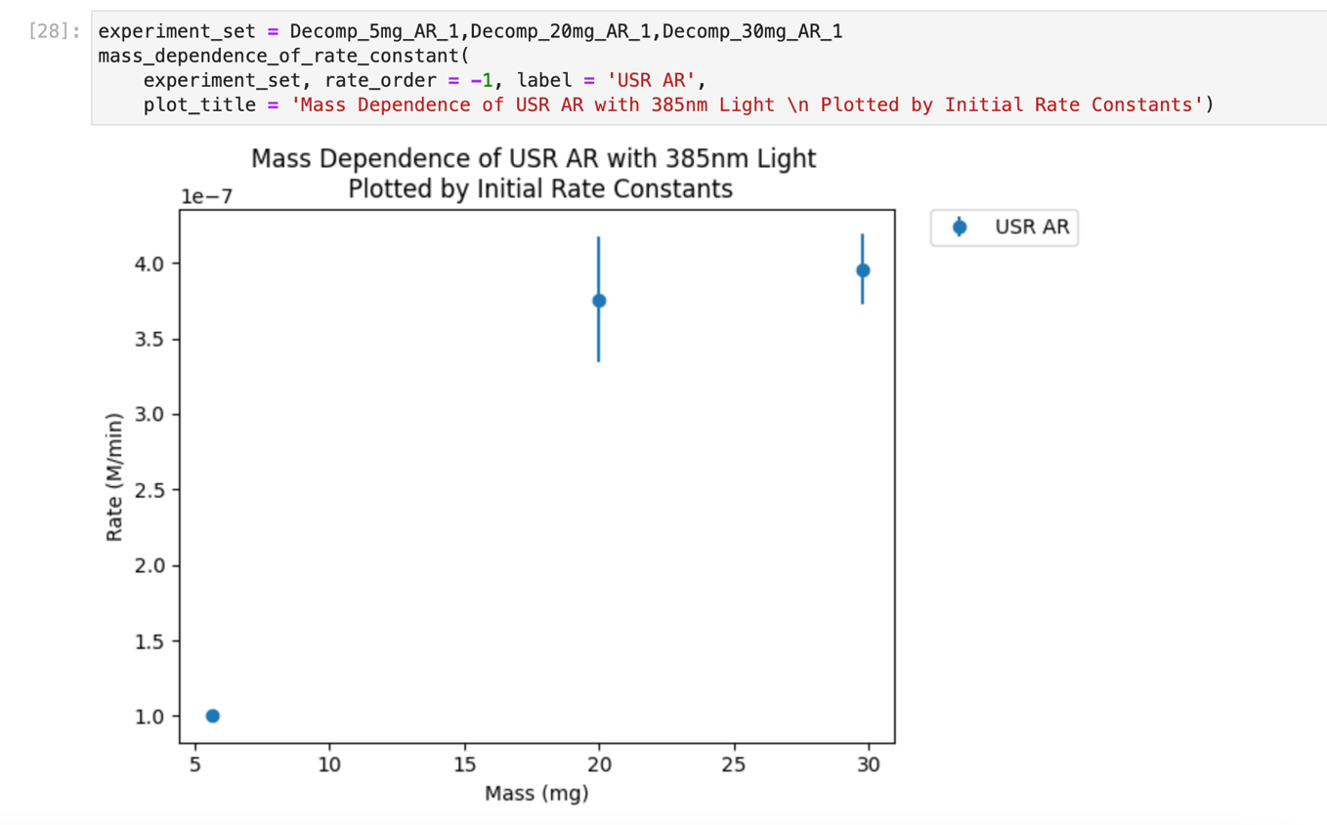

The user might want to know how their photocatalyst depends on a certain variable. These functions exist outside the Experiment object and need to be called with multiple data sets. As of version 3.0, there are three dependence functions, **wavelength_dependence_of_rate_constant(), current_dependence_of_rate_constant(), and mass_dependence_of_rate_constant().** They all function exactly the same, so this guide will only consider the mass dependence function. These functions take four arguments. The first of the two label, and plot_title which give names to the experiment set and title the figure the function produces. The two other arguments experiment_set and rate_order are necessary to read in the data and select the rate constants that will be used to evaluate the dependence. The value of rate_order can be values -1 to 1. Zeroth and first order rate constants are 0 and 1 respectively while -1 plots initial rates. As seen above, the experiment set that has been developed during this guide is plotted above with error bars.

**Organization**

Before ending the guide, it is important to mention that Jupyter is excellent for organizing data. Creating markdown command lines can be used to make sections to organize the data processing by using # symbols before words. By clicking on a command line and pressing M, a markdown command line can be created. By typing **# Title** **1 1**a section can be created. To make sub sections, insert another markdown command line and type **## Title 2.**



And if the user presses Shift + Enter Jupyter will format the sections as such:



Additionally, the user can create new command lines by clicking on a command line and pressing A for above or B for below.

### 2. Photodecomposition Program

"""  
Created on Wed May 22 14:07:53 2024  
  
@author: niallgushue  
"""  
  
import scipy as sp  
import numpy as np  
import matplotlib.pyplot as plt  
import pandas as pd  
import copy  
from scipy.interpolate import interp1d  
  
  
  
print("Analysis performed using Photodecomposotion Analysis Version 3.0 Created by Niall Gushue")  
print('''  
 Version 3.1 - Fixed Calibration Wavelength  
 - Major overhaul to organization  
 ''')  
  
#Patch Notes:  
  
 # Version 1.0  
 # - Added plotdecomp: Plots UV-Vis Decomposition  
   
 # Version 1.1  
 # - Added ratetime: Plots Concentration vs Time of Methyl Orange  
   
 # Version 1.2  
 # - Added linearfit: Adds a Linear Fit to the ratetime graph  
 # - Added expfit: Adds an Exponential Fit to the ratetime graph  
   
 # Version 2.1   
 # - Added getconcentration and gettimes: Allows the user to more easily access  
 # concentration and time arrays of the experiment. Cuts down on necessary code.  
   
 # Version 2.2  
 # - Added getexpfit and getlinerfit to extract the data points for these fits  
   
 # Version 2.3  
 # - Added getrateconstant to determine rate constant of linear and exponential fits  
   
 # Version 2.4  
 # - Added betterfit: determine whether the linear or expoential fit is better  
  
 # Version 2.4.4  
 # - debugged betterfit  
 # - betterfit now prints the chi squared values  
 # - different spectra can now be plotted against each other using ratetime,  
 # expfit and linearfit  
 # - added ability to create legends for ratetime  
  
 # Version 2.5  
 # - Added currentftime to plot rate as a function of current  
  
 # Version 2.6  
 # - Added weights which calculates the average weight and standard deviation od the  
 # weight measurements of photocatalyst  
  
 # Version 2.7  
 # - Added an option to average UV-Vis spectra to intial def function and report the uncertainity  
   
 # Version 3.0  
 # - Major overhaul to organization  
  
**class** **Experiment**:  
   
 #initial_labels = ['Stock', 't = 0','t = 10 min', 't = 20 min', 't = 30 min', 't = 40 min', 't = 60 min', 't = 80 min', 't = 100 min', 't = 120 min']  
   
 **def** **__init__**(**self**, path,  
 tare_mass_measurements, #mass of the empty bottle  
 catalyst_mass_measurements, #mass of the filled bottle  
 times = [0, 5, 15, 35, 75, 115],   
 current = -1,  
 LED_wavelength = 385,  
 avg = False,  
 particle_size = 0,  
 calibration_wavelength = 466.6,  
 MO_stock_conc = 3.263e-5):  
   
 **self**.MO_initial_conc = MO_stock_conc  
   
 **if** particle_size != 0:  
 **self**.particle_size = particle_size  
   
 **if** current != -1:  
 **self**.current = current  
   
 **self**.LED_wavelength = LED_wavelength  
   
 **self**.times = np.array(times)  
 **self**.catalyst_mass_measurements = np.array(catalyst_mass_measurements)  
 **self**.tare_mass_measurements = np.array(tare_mass_measurements)  
 **if** **not** avg:  
 **self**.data = pd.read_excel(path)  
 **self**.wavelength = **self**.data.iloc[:,::2]  
 **self**.absorbance = **self**.data.iloc[:,1::2]  
 **self**.wavelength_drop = **self**.wavelength.dropna(how= "all", axis=1) #drops empty sheets  
 **self**.absorbance_drop = **self**.absorbance.dropna(how= "all", axis=1) #drops empty sheets  
 **self**.N = len(**self**.wavelength_drop.iloc[0,:]) #Number of Columns  
 **self**.NN = len(**self**.wavelength_drop.iloc[:,0]) #Number of Rows  
 **self**.std = 0  
 **self**.did_average = False  
   
 #implement code to averafe three measurements of absorbance  
 **if** avg:  
 **self**.data = pd.read_excel(path)  
 # self.data.astype(float)  
   
 abs_1 = **self**.data.iloc[:,1::6].to_numpy()  
 abs_2 = **self**.data.iloc[:,3::6].to_numpy()  
 abs_3 = **self**.data.iloc[:,5::6].to_numpy()  
 abs_avg = (abs_1 + abs_2 + abs_3) / 3  
 abs_df = pd.DataFrame(abs_avg)  
   
 abs_std_1 = np.sqrt((abs_1 - abs_avg)**2 / 2)  
 abs_std_2 = np.sqrt((abs_2 - abs_avg)**2 / 2)  
 abs_std_3 = np.sqrt((abs_3 - abs_avg)**2 / 2)  
 abs_std_avg = (abs_std_1 + abs_std_2 + abs_std_3) / 3  
 std_df = pd.DataFrame(abs_std_avg)  
   
 wav_1 = **self**.data.iloc[:,::6].to_numpy()  
 wav_2 = **self**.data.iloc[:,2::6].to_numpy()  
 wav_3 = **self**.data.iloc[:,4::6].to_numpy()  
 wav_avg = (wav_1 + wav_2 + wav_3) / 3  
 wav_df = pd.DataFrame(wav_avg)  
   
 **self**.std = std_df  
 **self**.std = **self**.std.dropna(how= "all", axis=1) #drops empty sheets  
 **self**.wavelength = wav_df  
 **self**.absorbance = abs_df  
 **self**.wavelength_drop = **self**.wavelength.dropna(how= "all", axis=1) #drops empty sheets  
 **self**.absorbance_drop = **self**.absorbance.dropna(how= "all", axis=1) #drops empty sheets  
   
 **self**.N = len(abs_df.iloc[0,:]) #Number of Columns  
 **self**.NN = len(abs_df.iloc[:,0]) #Number of Rows  
   
 **self**.did_average = True  
   
 **self**.calibration_wavelength = calibration_wavelength  
 **self**.getconcentration()  
 **self**.linearfit()  
 **self**.expfit()  
 **self**.masses()  
 **self**.find_initial_rate_constant()  
   
 **def** **plotdecomp**(**self**,label = '', ylim_max = 0.88):  
 **for** i **in** range(0,**self**.N):  
 plt.plot(**self**.wavelength_drop.iloc[:,i],**self**.absorbance_drop.iloc[:,i], label = **self**.time_labels[i])  
 plt.xlim(250,700)  
 plt.ylim(0,ylim_max)  
 plt.title(label)  
 plt.xlabel('Wavelength (nm)')  
 plt.ylabel('Absorbance')  
 plt.legend(bbox_to_anchor=(1.05, 1), loc='upper left', borderaxespad=0)  
   
   
   
   
 @property  
 **def** **time_labels**(**self**):  
 strlist = ['Stock']  
 strlist += [str(time) **for** time **in** **self**.times]  
 **for** index, time **in** enumerate(strlist[1:]):  
 strlist[index+1] = 't = ' + time + ' min'  
   
 **return** strlist  
   
   
   
  
 **def** **getconcentration**(**self**):  
   
   
 NN = len(**self**.wavelength_drop.iloc[:,0]) #Number of Rows  
 indexes = []  
 **for** i **in** range(0,NN):  
 **for** j **in** range(0,**self**.N):  
 **if** **self**.wavelength_drop.iloc[i,j] < **self**.calibration_wavelength + 0.001 **and** **self**.wavelength_drop.iloc[i,j] > **self**.calibration_wavelength - 0.001:  
 indexes.append(i)  
   
 absorbances_at_wavelength = []  
 std_at_wavelength = []  
   
 # if len(indexes) == 0:  
   
 # for i in range(0,self.N):  
 # indexes.append(376)  
   
 **for** i **in** range(0,**self**.N):  
 ab = **self**.absorbance_drop.iloc[indexes[i],i]  
 absorbances_at_wavelength.append(ab)  
   
 conc_std = 0  
 **if** **self**.did_average:  
 **for** i **in** range(0,**self**.N):  
 stds = **self**.std.iloc[indexes[i],i]  
 std_at_wavelength.append(stds)  
 conc_std = std_at_wavelength  
   
   
 std_at_wavelength.remove(std_at_wavelength[0])  
   
 absorbances_at_wavelength.remove(absorbances_at_wavelength[0]) #to remove the stock  
   
   
 absorptivity_MO = 25701 #cm-1 * M-1  
   
 concentrations = []  
 **for** i **in** range(0,**self**.N-1):  
 M = absorbances_at_wavelength[i] / absorptivity_MO  
 concentrations.append(M)  
   
 **self**.concentrations = concentrations  
 **self**.std = conc_std  
   
 **return**  
   
   
 **def** **plot_ratetime**(**self**, plot_title = '', label = ''):  
   
   
 small_y = min(**self**.concentrations) - 1e-5  
 high_y = max(**self**.concentrations) + 1e-5  
 plt.ylim(small_y,high_y)  
  
 plt.plot(**self**.times, **self**.concentrations, label = label)  
 plt.title(plot_title)  
 plt.xlabel('Time (min)')  
 plt.ylabel('Concentration(M)')  
   
 **def** **plot_linearfit**(**self**, plot_title = '', label = '', color_dot = 'yo', color_line = '--k'):  
   
   
 small_y = min(**self**.concentrations) - 1e-5  
 high_y = max(**self**.concentrations) + 1e-5  
  
 #y = self.concentrations  
 #x = self.times  
   
 #coef = np.polyfit(x,y,1)  
 #poly1d_fn = np.poly1d(coef)   
 # poly1d_fn is now a function which takes in x and returns an estimate for y  
   
 #plt.plot(self.times,self.concentrations, label = 'Raw Data')  
 plt.plot(**self**.times,**self**.concentrations, color_dot)   
 plt.plot(**self**.times, **self**.concentrations_linear_fit, color_line, label = label) #'--k'=black dashed line, 'yo' = yellow circle marker  
   
 plt.title(plot_title)  
 plt.ylim(small_y,high_y)  
 plt.xlabel('Time (min)')  
 plt.ylabel('Concentration(M)')  
 plt.legend()  
   
   
 k = **self**.slope_linear_fit  
 b = **self**.intercept_linear_fit  
   
 print(f'The Linear Fit Equation is: Conc = {-k:.2e}*t + {b:.2e}')  
   
 **def** **linearfit**(**self**):  
  
 coef = np.polyfit(**self**.times,**self**.concentrations,1)  
   
 poly1d_fn = np.poly1d(coef)   
   
 concentrations_linear_fit = poly1d_fn(**self**.times)  
   
 **if** **self**.did_average:  
 std = np.array(**self**.std)  
   
   
 weight = 1/(std**2)  
   
 p,V = np.polyfit(**self**.times, **self**.concentrations, 1, w = weight, cov = True)  
   
 else:  
 p,V = np.polyfit(**self**.times, **self**.concentrations, 1, cov = True)  
 weight = 0  
   
 **self**.concentrations_linear_fit = concentrations_linear_fit  
 **self**.intercept_linear_fit = p[1]  
 **self**.slope_linear_fit = -p[0] #this is a rate constant, essentially  
 **self**.variance_linear_fit = V  
 **self**.weight_linear_fit = weight  
   
 uncert = np.sqrt(**self**.variance_linear_fit[0][0])  
 **self**.linear_rate_constant_uncertainty = uncert  
   
 **self**.linear_residual = **self**.concentrations_linear_fit - **self**.concentrations  
   
 **self**.linear_chisq = sum(**self**.linear_residual**2 / np.array(**self**.std) **2)  
   
   
 #if self.did_average:  
 #self.linear_reduced_chisq = self.reduced_chi_squared(self.concentrations_linear_fit)  
   
 #self.linear_pearson_chisq = np.sum((self.linear_residual**2) / self.concentrations)  
   
 **def** **expfit**(**self**):  
   
 exponential_fit = np.polyfit(**self**.times, np.log(**self**.concentrations), 1)  
 pre_exponential = np.exp(exponential_fit[1])  
 exponential_constant = exponential_fit[0]  
   
 concentrations_exponential_fit = pre_exponential * np.exp(exponential_constant * **self**.times)  
   
   
 **self**.concentrations_exponential_fit = concentrations_exponential_fit  
 **self**.pre_exponential = pre_exponential  
 **self**.exponential_constant = -exponential_constant  
   
 **self**.exp_residual = **self**.concentrations_exponential_fit - **self**.concentrations  
   
 **self**.exp_chisq = np.sum(**self**.exp_residual**2 / np.array(**self**.std) **2)  
   
 **if** **self**.did_average:  
 std = np.array(**self**.std)  
   
   
 weight = 1/(std**2)  
   
 p,V = np.polyfit(**self**.times, np.log(**self**.concentrations), 1, w = weight, cov = True)  
   
 **self**.variance_exp_fit = V  
   
 uncert = np.sqrt(**self**.variance_exp_fit[0][0])  
   
 **self**.exp_rate_constant_uncertainty = uncert  
   
 else:  
 **self**.exp_rate_constant_uncertainty = 0  
   
   
 # self.exp_rate_constant_uncertainty = np.average(np.array(self.std)) * self.exp_rate_constant  
   
 #self.exp_reduced_chisq = self.reduced_chi_squ ared(stddev, experimental_values, fit_values)  
 #if self.did_average:  
 #self.exp_reduced_chisq = self.reduced_chi_squared(self.concentrations_exponential_fit)  
   
   
   
   
 **def** **plot_expfit**(**self**, plot_title = '', label = '', color_dot = 'yo', color_line = '--k'):  
   
   
 small_y = min(**self**.concentrations) - 1e-5  
 high_y = max(**self**.concentrations) + 1e-5  
   
   
 plt.plot(**self**.times,**self**.concentrations, color_dot)   
 #plt.plot(self.times,self.concentrations, label = 'Raw Data')   
 plt.plot(**self**.times, **self**.concentrations_exponential_fit, color_line, label = label) #'--k'=black dashed line, 'yo' = yellow circle marker  
   
 plt.title(plot_title)  
 plt.ylim(small_y,high_y)  
 plt.xlabel('Time (min)')  
 plt.ylabel('Concentration(M)')  
   
 k = **self**.exp_rate_constant  
   
 print(f'The Exponential Fit Equation is: Conc = {self.pre_exponential:.2e} * exp({-k:.2e}*t)')  
   
   
 **def** **find_linear_rate_constant**(**self**):  
 uncert = np.sqrt(**self**.variance_linear_fit[0][0])  
 k = **self**.slope_linear_fit  
 print(f"The linear rate constant is: {k:.3e} +/- {uncert/k*100:.2f}%")  
   
 **self**.linear_rate_constant_uncertainty = uncert  
   
  
 @property  
 **def** **linear_rate_constant**(**self**):  
 **return** **self**.slope_linear_fit  
   
 # **@property**  
 # def initial_rate_constant(self):  
 # return self.initial_rate_constant  
   
 @property  
 **def** **exp_rate_constant**(**self**):  
 **return** **self**.exponential_constant  
   
 **def** **find_exp_rate_constant**(**self**):  
 k = **self**.exponential_constant  
 uncert = **self**.exp_rate_constant_uncertainty  
   
 print(f"The exponential rate constant is: {k:.3e} +/- {uncert/k*100:.2f}%")  
   
   
 **def** **compare_fit_quality_no_print**(**self**):  
   
 **if** **self**.linear_chisq < **self**.exp_chisq:  
 **return** True  
 else:  
 **return** False  
   
 **def** **compare_fit_quality**(**self**):  
   
 **if** **self**.linear_chisq < **self**.exp_chisq:  
 print('linear fit better')  
 print(f'linear chi squared: {self.linear_chisq:.2e}\t exponential chi squared: {self.exp_chisq:.2e} ')  
 **return** True  
 else:  
 print('exponential fit better')  
 print(f'linear chi squared: {self.linear_chisq:.2e}\t exponential chi squared: {self.exp_chisq:.2e} ')  
 **return** False  
   
 **def** **find_initial_rate_constant**(**self**, override = -1, exp_estimate = 0):  
 **self**.fit_test = **self**.compare_fit_quality_no_print()  
   
 **if** override == 0:  
 **self**.fit_test = True  
   
 **if** override == 1:  
 **self**.fit_test = False  
   
 **if** **self**.fit_test == True:  
 **self**.linearfit()  
 **self**.initial_rate_constant = **self**.linear_rate_constant  
 **self**.initial_rate_constant_uncertainty = **self**.linear_rate_constant_uncertainty  
   
 **if** **self**.fit_test == False:  
 **self**.expfit()  
   
 initial_concentrations = []  
 #initial_times = [0,5]  
   
 **if** exp_estimate == 0:  
  
 initial_concentrations.append(**self**.concentrations_exponential_fit[0])  
 initial_concentrations.append(**self**.concentrations_exponential_fit[1])  
 initial_concentrations.append(**self**.concentrations_exponential_fit[2])  
   
 slope = (initial_concentrations[1] - initial_concentrations[0]) / 15  
   
 **if** exp_estimate == 1: #tighter estimate  
  
 initial_concentrations.append(**self**.concentrations_exponential_fit[0])  
 initial_concentrations.append(**self**.concentrations_exponential_fit[1])  
   
 slope = (initial_concentrations[1] - initial_concentrations[0]) / 5  
   
 **if** exp_estimate == 2: ## ro = k1 * Co  
   
 #slope = -self.exp_rate_constant * self.concentrations_exponential_fit[0]  
   
 slope = -**self**.exp_rate_constant * **self**.MO_initial_conc  
   
 else:  
 **self**.initial_rate_constant_uncertainty = (  
 **self**.exp_rate_constant_uncertainty * **self**.concentrations_exponential_fit[0])  
   
 **self**.initial_rate_constant = -slope  
   
 **if** **not** **self**.did_average:  
 **self**.initial_rate_constant_uncertainty = **self**.initial_rate_constant / 2  
   
 print(f'The Initial Rate Constant is: {self.initial_rate_constant:.2e}')  
   
 **def** **masses**(**self**):  
  
 **self**.catalyst_masses = (**self**.catalyst_mass_measurements - **self**.tare_mass_measurements)*1000 #in mg  
 **self**.mean_catalyst_mass = np.average(**self**.catalyst_masses) #in mg  
 **self**.stddev_catalyst_mass = np.std(**self**.catalyst_masses) #in mg  
  
 print("The Catalyst Mass is",**self**.mean_catalyst_mass, "+/-", **self**.stddev_catalyst_mass, 'mg')  
 **return**  
   
 @property  
 **def** **catalyst_mass**(**self**):  
 **return** **self**.mean_catalyst_mass  
   
 **def** **reduced_chi_squared**(**self**, fit_values, degrees_of_freedom =2):  
 variance = np.array(**self**.std)**2  
 residual = **self**.concentrations - fit_values  
 chi_squared = np.sum(residual**2/variance)  
 result = chi_squared/degrees_of_freedom  
 **return** result  
   
  
**class** **Avg_Experiment**:  
  
 **def** **__init__**(**self**, experiment_set):  
 masses = []  
 rate_constants = []  
 uncertainties = []  
   
 **for** experiment **in** experiment_set:  
   
 masses.append(experiment.catalyst_mass)  
 rate_constants.append(experiment.initial_rate_constant)  
 uncertainties.append(experiment.initial_rate_constant_uncertainty)  
   
 **self**.initial_rate_constant = np.average(np.array(rate_constants))  
 **self**.initial_rate_constant_uncertainty = np.std(np.array(rate_constants))  
 **self**.catalyst_mass = np.average(np.array(masses))  
   
 print(f'The Average Rate Constant is: Conc = {self.initial_rate_constant:.2e} +/- {self.initial_rate_constant_uncertainty:.2e})')  
   
   
   
   
   
**def** **mass_dependence_of_rate_constant**(experiment_set, rate_order = 0, label = '',   
 plot_title = '', smooth = 0, point = 'o'):  
 masses = []  
 rate_constants = []  
 uncertainties = []  
  
 **for** experiment **in** experiment_set:  
   
 masses.append(experiment.catalyst_mass)  
 **if** rate_order == 0:  
 rate_constants.append(experiment.linear_rate_constant)  
 uncertainties.append(experiment.linear_rate_constant_uncertainty)  
 elif rate_order == 1:  
 rate_constants.append(experiment.exp_rate_constant)  
 uncertainties.append(experiment.exp_rate_constant_uncertainty)  
 elif rate_order == -1:  
 rate_constants.append(experiment.initial_rate_constant)  
 uncertainties.append(experiment.initial_rate_constant_uncertainty)  
   
 **if** smooth == 0:   
   
 **if** len(uncertainties) == 0:  
 plt.plot(masses,rate_constants,point, label = label)  
   
   
   
 **if** len(uncertainties) > 0:  
 plt.errorbar(masses, rate_constants, yerr=uncertainties,fmt = point, label = label)  
 plt.title(plot_title)  
 plt.xlabel('Mass (mg)')  
 plt.ylabel('Rate (M/min)')  
   
 **if** rate_order == -1:  
 plt.ylabel('Initial Rate (M/min)')  
   
 **if** len(label) > 0:  
 plt.legend(bbox_to_anchor=(1.05, 1), loc='upper left', borderaxespad=0)  
   
 # masses = np.array(masses)  
 # rate_constants = np.array(rate_constants)  
 # y_err = np.array(uncertainties)  
   
 **if** smooth == 1:  
   
 from scipy.interpolate import make_interp_spline   
   
 x = masses  
 y = rate_constants   
   
 xnew = np.linspace(min(x), max(x), 300)   
   
 gfg = make_interp_spline(x, y, k=3)   
   
 y_new = gfg(xnew)   
   
 plt.plot(xnew, y_new,'--',label = label)   
   
 **if** len(label) > 0:  
 plt.legend(bbox_to_anchor=(1.05, 1), loc='upper left', borderaxespad=0)  
   
 plt.title(plot_title)  
   
 plt.xlabel('Mass (mg)')  
 plt.ylabel('Initial Rate (M/min)')  
   
   
   
   
**def** **current_dependence_of_rate_constant**(experiment_set, rate_order = 0, label = '', plot_title = ''):  
 currents = []  
 rate_constants = []  
 uncertainties = []  
   
 **for** experiment **in** experiment_set:  
 currents.append(experiment.current)  
 **if** rate_order == 0:  
 rate_constants.append(experiment.linear_rate_constant)  
 uncertainties.append(experiment.linear_rate_constant_uncertainty)  
 elif rate_order == 1:  
 rate_constants.append(experiment.exp_rate_constant)  
 uncertainties.append(experiment.exp_rate_constant_uncertainty)  
 elif rate_order == -1:  
 rate_constants.append(experiment.initial_rate_constant)  
 uncertainties.append(experiment.initial_rate_constant_uncertainty)  
   
 **if** len(uncertainties) == 0:  
 plt.plot(currents,rate_constants,'o', label = label)  
   
   
   
 **if** len(uncertainties) > 0:  
 plt.errorbar(currents, rate_constants, yerr=uncertainties,fmt = 'o', label = label)  
   
 plt.title(plot_title)  
 plt.xlabel('Current (mA)')  
 plt.ylabel('Rate (M/min)')  
 **if** len(label) > 0:  
 plt.legend(bbox_to_anchor=(1.05, 1), loc='upper left', borderaxespad=0)  
   
   
  
**def** **wavelength_dependence_of_rate_constant**(experiment_set, rate_order = 0, label = '', plot_title = ''):  
 wavelengths = []  
 rate_constants = []  
 uncertainties = []  
   
 **for** experiment **in** experiment_set:  
 wavelengths.append(experiment.LED_wavelength)  
 **if** rate_order == 0:  
 rate_constants.append(experiment.linear_rate_constant)  
 uncertainties.append(experiment.linear_rate_constant_uncertainty)  
 elif rate_order == 1:  
 rate_constants.append(experiment.exp_rate_constant)  
 uncertainties.append(experiment.exp_rate_constant_uncertainty)  
 elif rate_order == -1:  
 rate_constants.append(experiment.initial_rate_constant)  
 uncertainties.append(experiment.initial_rate_constant_uncertainty)  
   
   
 plt.plot(wavelengths,rate_constants, 'o', label = label)  
 #if len(uncertainties) > 0:  
 #plt.errorbar(currents, rate_constants, yerr=uncertainties,fmt = 'o', label = label)  
 plt.title(plot_title)  
 plt.xlabel('Wavelength (nm)')  
 plt.ylabel('Rate (M/min)')  
 **if** len(label) > 0:  
 plt.legend()  
   
**def** **particle_dependence_of_rate_constant**(experiment_set, rate_order = 0, label = '', plot_title = ''):  
 particles = []  
 rate_constants = []  
 uncertainties = []  
   
 **for** experiment **in** experiment_set:  
 particles.append(experiment.particle_size)  
 **if** rate_order == 0:  
 rate_constants.append(experiment.linear_rate_constant)  
 uncertainties.append(experiment.linear_rate_constant_uncertainty)  
 elif rate_order == 1:  
 rate_constants.append(experiment.exp_rate_constant)  
 elif rate_order == -1:  
 rate_constants.append(experiment.initial_rate_constant)  
   
   
 **if** len(uncertainties) > 0:  
 plt.errorbar(particles, rate_constants, yerr=uncertainties,fmt = 'o', label = label)  
 plt.title(plot_title)  
 plt.xlabel('Mass (mg)')  
 plt.ylabel('Rate (M/min)')  
   
   
 **if** len(uncertainties) == 0:  
 plt.plot(particles,rate_constants,'o', label = label)

#if len(uncertainties) > 0:  
 #plt.errorbar(currents, rate_constants, yerr=uncertainties,fmt = 'o', label = label)  
 plt.title(plot_title)  
 plt.xlabel('Particle Size (µm)')  
 plt.ylabel('Rate (M/min)')  
 **if** len(label) > 0:  
 plt.legend()   
   
 **if** rate_order == -1:  
 plt.ylabel('Initial Rate (M/min)')

## References